MRMQuant

User Guide

Version 1.0

2024 04/20

Table of Content

Part A. System Requirement and Installation ………………………………………………………..3

1. Minimum System Requirement ..………………………………………………………………………………………..3
2. Installation Steps ………………………………………………………………………………………………………………..3
3. Contact Information ……………………………………………………………………………………………………………7
4. System Overview ………………………………………………………………………………………………………………..7

Part B. Step-by-Step illustration ……………………………………………………………………………..9

1 Start MRMQuant ………………………………………………………………………………………………………………..9

2 Select an experiment type ………………………………………………………………………………………………….9

3 Load MRM sample files …………………………………………………………………………………………………….10

4 Load/Modify compound information ………………………………………………………………………………..11

5 Adjust quantitation parameters …………………………………………………………………………………………14

6 Start the quantitation ………………………………………………………………………………………………………..14

7 Export the heatmap plot ……………………………………………………………………………………………………16

8 Expand/shrink and show the heatmap/TIC plot …………………………………………………………………17

9 Activate/deactivate inspection mode …………………………………………………………………………………18

10 Show batch effect correction ………………………………………………………………………………………….….29

11 Heatmap options …………………………………………………………………………………………………………..…..32

12 Quantitation message ………………………………………………………………………………………………………..34

13 Standard curve generation …………………………………………………………………………………………………35

14 Input/Output the quantitation result …………………………………………………………………………………44

**Part A. System Requirement and Installation**

1. Minimum System Requirement:

Windows 10 or higher

CPU: Intel® Core™ i5 CPU

Memory: 8 GB

System type: 64-bit operation system

1. Installation Steps

(i) Make sure the computer is internet assessable.

(ii) Execute the “MyAppInstaller\_web.exe”.

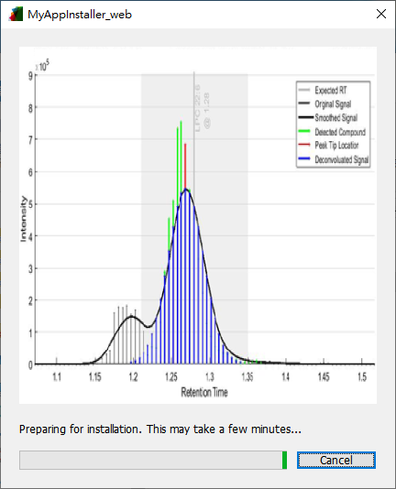

(iii) Click "Next" in the following window.

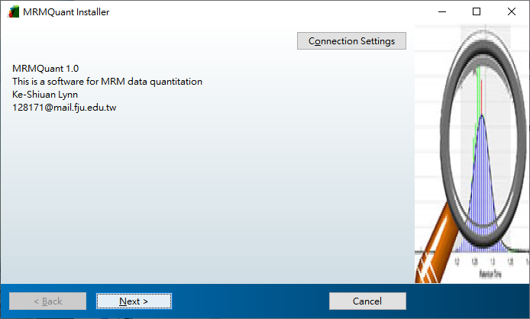

(iV) Select the folder in which the MRMQuant is to be installed, choose whether to create a shortcut to the desktop, and then click “Next”.

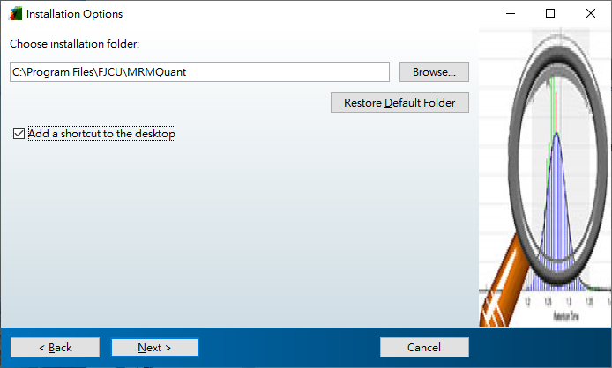

(v) If no MATLAB Runtime is ever installed, select the folder in which the MATLAB Runtime is to be installed and click "Next". Otherwise, if and different version of MATLAB Runtime has been installed, the program will install the MATLAB Runtime R2022a to the existing folder.

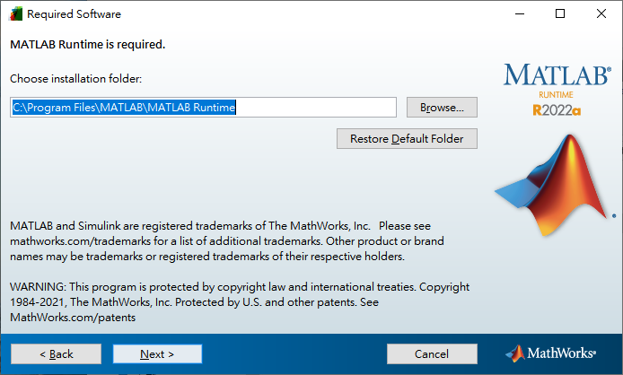

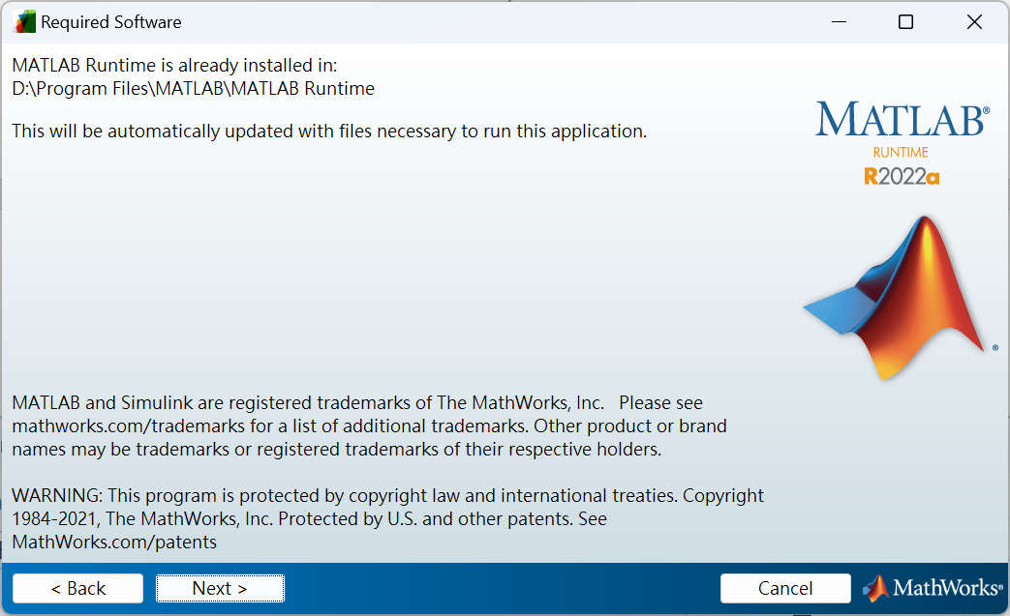

(vi) Click "Install" in the following window

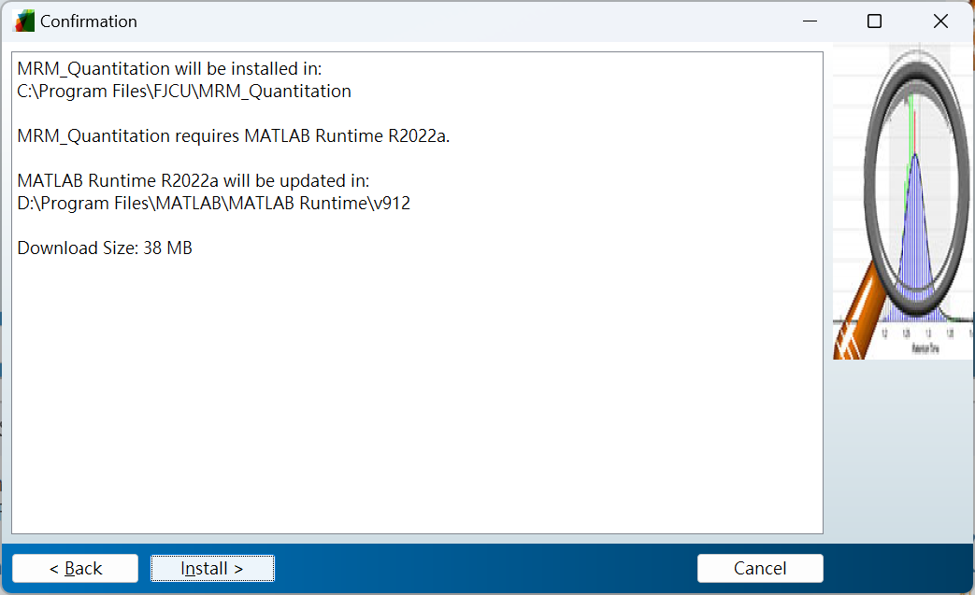

(vii) Installation is in progress

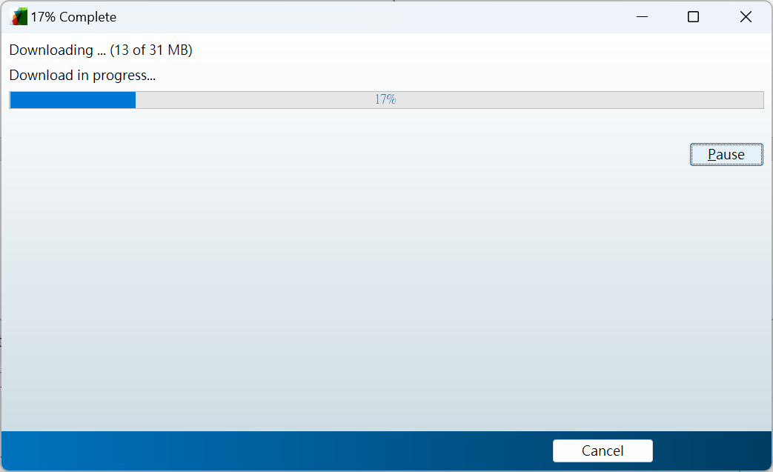

(viii) Click "Finish" in the following window to close the window.

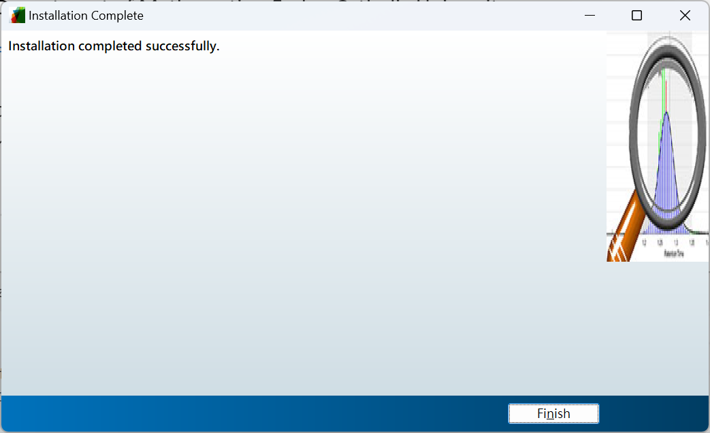

(ix) Copy the “data folder” and the “MRM\_Method.csv” to your test data folder (optional).

(x) Execute MRMQuant from the application list.



(xi) The starting logo

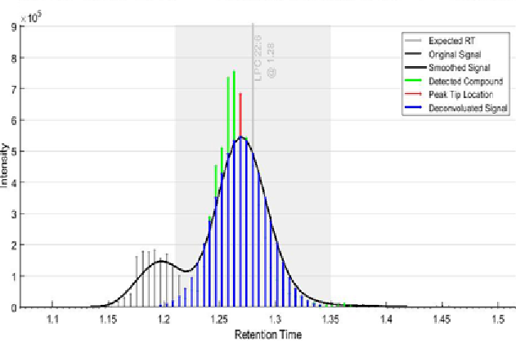

(xii) The program outlook



1. Contact Information

Name: Dr. Ke-Shiuan Lynn

Affiliation: Department of Mathematics, Fu Jen Catholic University

Email: [128171@mail.fju.edu.tw](mailto:128171@mail.fju.edu.tw)

1. System Overview

Figure 1 shows the key panels in the MRMQuant GUI. To perform quantitation to a set of sample files, the user needs to provide data and information in panels (a) through (c) in sequence. At the beginning, only the “Experiment Data” panel (panel (a)) is activated and the user selects an experiment type and loads the sample files in the panel. The files are loaded in the acquiring order for the subsequent batch effect correction. After all the sample files being loaded, the total ion chromatogram (TIC) of the first file will be shown in panel (e). Users can view the TIC of another file by clicking on its file name in panel (a). At this stage, the “Compound Information” panel (panel (b)) will be activated allowing the method file, which providing the com-pound-related information, to be loaded herein. Upon loaded, the compound names and their corresponding locations (RT) will be noted in the TIC. Then, the “Quantitation Parameters” panel (panel (c)) will be activated and the parameters including peak finding, peak deconvolution, and batch effect correction are to be input herein. Finally, the use can press the “Start Quantitation” button to start the quantitation process. During the quantitation process, the quantitation result in the heatmap form will be displayed in panel (e) and the complete percentage will be shown in panel (f).

C:\Users\User\AppData\Local\Microsoft\Windows\INetCache\Content.Word\Figure2_MRMQuant_main_section_300pt.tif

Figure 1. Key panels in the MRMQuant GUI (a) Experiment Data, (b) Compound Information, (c) Quantitation Parameters, (d) Quantitation Buttons, (e) TIC or Heatmap, (f) Progress Bar.

Figure 2 illustrates the workflow of MRMQuant. Briefly, the quantitation procedure starts from selecting a suitable experiment type followed by loading MRM sample files and a method file which provides the necessary information about the targeted compounds into the system. After setting the quantitation parameters, peaks in each of the sample files are detected and the ones corresponding to the targeted compounds are quantitated. Once the targeted compounds being quantitated in all the sample files, batch effect correction will be conducted if quality control (QC) samples are included in the sample files. Afterward, quantitation result is displayed for inspection and manual correction of the quantitated peaks can be made if required. For each quantitated compound, ab-solute concentration can be converted from the computed abundance via its corresponding IS of known concentration and/or a standard curve generated via a series of standard compounds of known concentrations. Similar quantitation procedure will be performed on the SC MRM files and absolute concentrations are to be converted from the computed abundances via the SCs. Finally, the quantitation result, including calculated abundances, concentrations, quantitation status, and retention times, and SC functions for all the targeted compounds will be exported to a Microsoft Excel file. In addition, a Matlab mat file will also be generated, which can be loaded into MRMQuant in the future to inspect and correct the existing quantitation result.

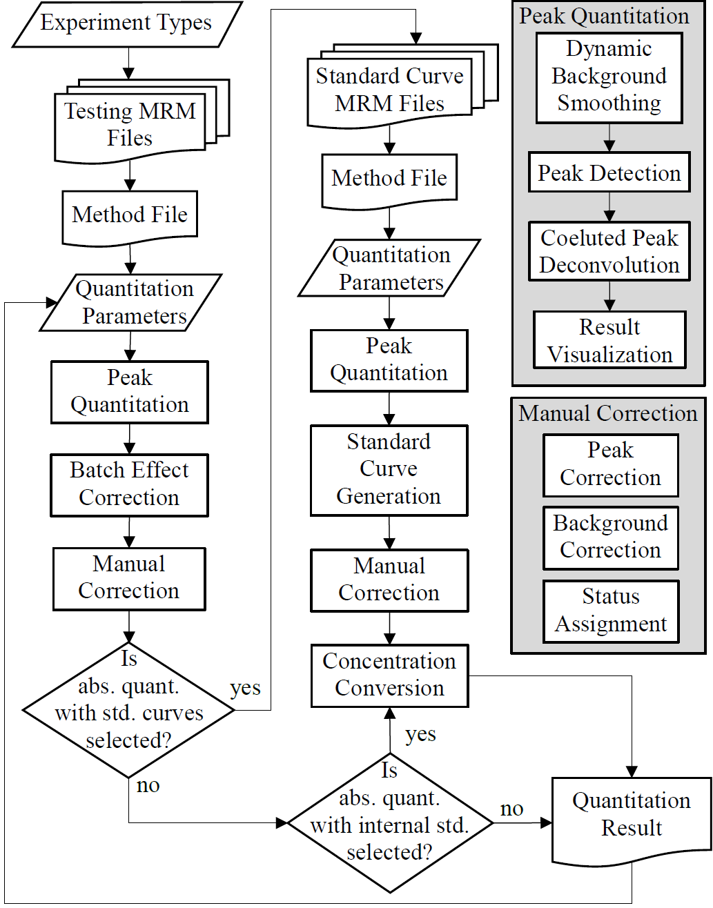

Figure 2. System Flowchart. The gray boxes in the right-hand side list the detailed functions in the peak quantitation and in the manual correction modules, respectively.

**Part B. Step-by-Step illustration**

1. **Start MRMQuant:** MRMQuant can beinvoked by two methods, depending whether MATLAB has been installed in your computer. All the required files can be downloaded from <https://github/MRMQuant>. If MATLAB is not installed in your computer, download the files from the executable files from <https://github/MRMQuant/program/executable>. Double click on the **"**MRMQuant.exe" file in the folder to start MRMQuant, as shown in Figure 1(a). On the other hand, if MATLAB has already in your computer, download the MATLAB files from <https://github/MRMQuant/program/MATLAB_source_code> and then start MATLAB and run MRMQuant.m (as shown in Figure 1(b)) in the MATLAB editor. A graphical user interface should appear as shown below. At this stage, the **Experiment Data** panel will be activated for users to input MRM data-related information, as indicated by the red block in Figure 2.

|  |  |
| --- | --- |
| Execute MRMQuant via the executable file | Execute MRMQuant via Matlab .m file |
|  |  |
| (a) | (b) |

Figure 1. Two methods to start MRMQuant. (a) Users with MATLAB (b) Uses without MATLAB.

1. **Select an experiment type:** In the "Experiment Data" panel, users need to first select a data type, as shown by the red block in Figure 3. In MRMQuant, there are 3 options: absolute quant. w/ int. std, absolute quant. w/ std. curve, and relative quantitation. The first type was designed to compute concentrations (e.g., mol./mL.) of targeted compounds in the MRM sample files via internal standards of known concentrations intentionally put in the samples. Similar to the first type, the second type was designed to compute concentrations via standard curves constructed using another set of sample files with targeted compounds of known concentrations. The third type, on the other hand, was designed to compute relative abundances of the targeted compounds. The abundance means the integrated peak signals in an ion chromatogram in an MRM sample file.

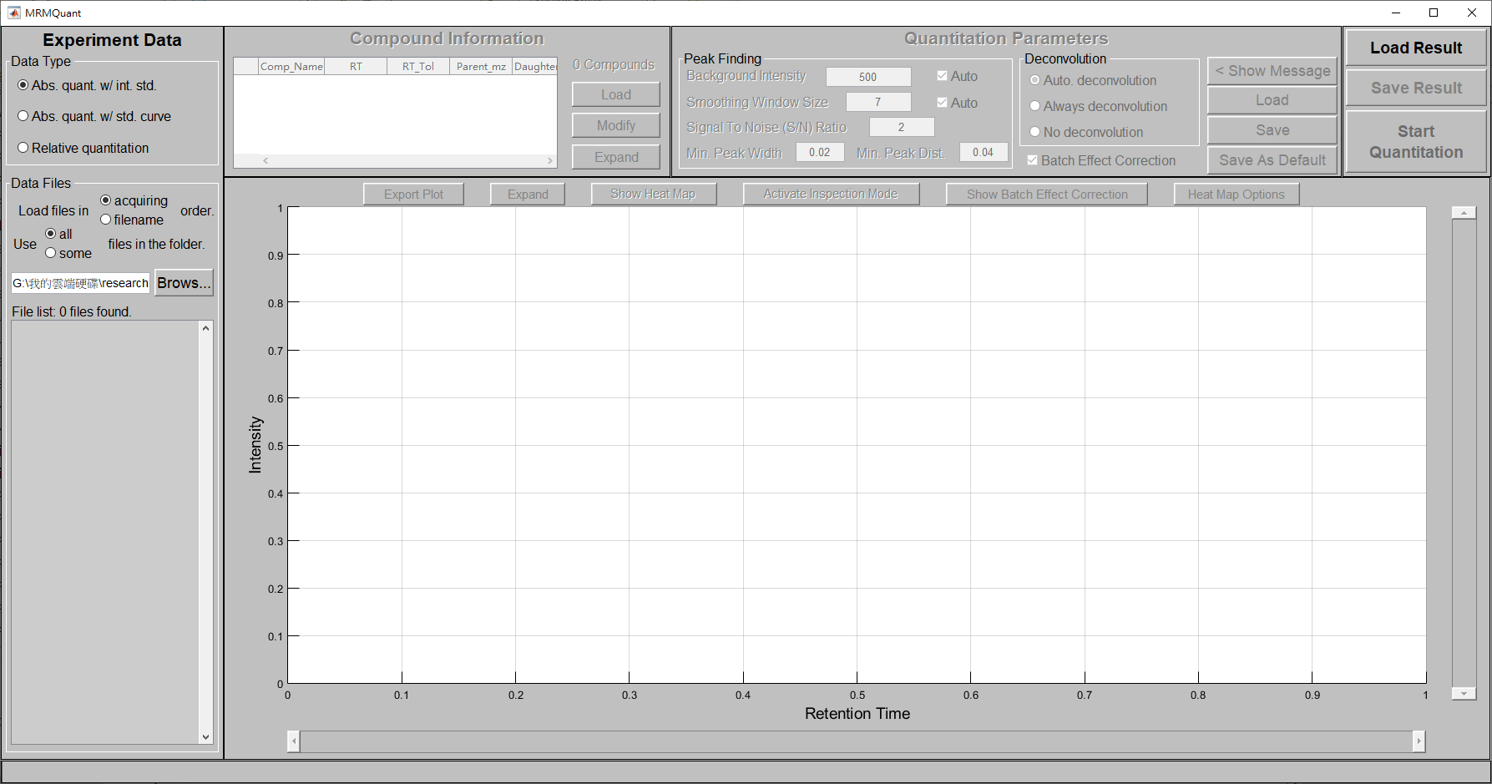

Figure 2. The graphical user interface of MRMQuant and the Experiment Data panel.



Figure 3. The data type panel in MRMQuant.

1. **Load MRM sample files:** Before the sample data is loaded into the system, users should select the order of how files are to be loaded, in acquiring or in file name order. The file order is important if batch effect correction is to be performed during the quantitation (refer to the batch effect connection section). In addition, users can also determine how many files in the specified folder are to be loaded, full or partial files in the folder. Once the file loading order and amount are determined, click the "Browse…" button in the left panel to select the folder/files to be quantitated, as shown in Figure 4. The program should start to load all the sample files in the folder. A progress bar at the bottom of the interface provides the progress of the file-reading process (Figure 5). After all the data files are loaded, users can click on a file name in the left panel to inspect its corresponding total ion chromatogram (TIC).



Figure 4. The “Data Files” panel for the import of MRM sample files

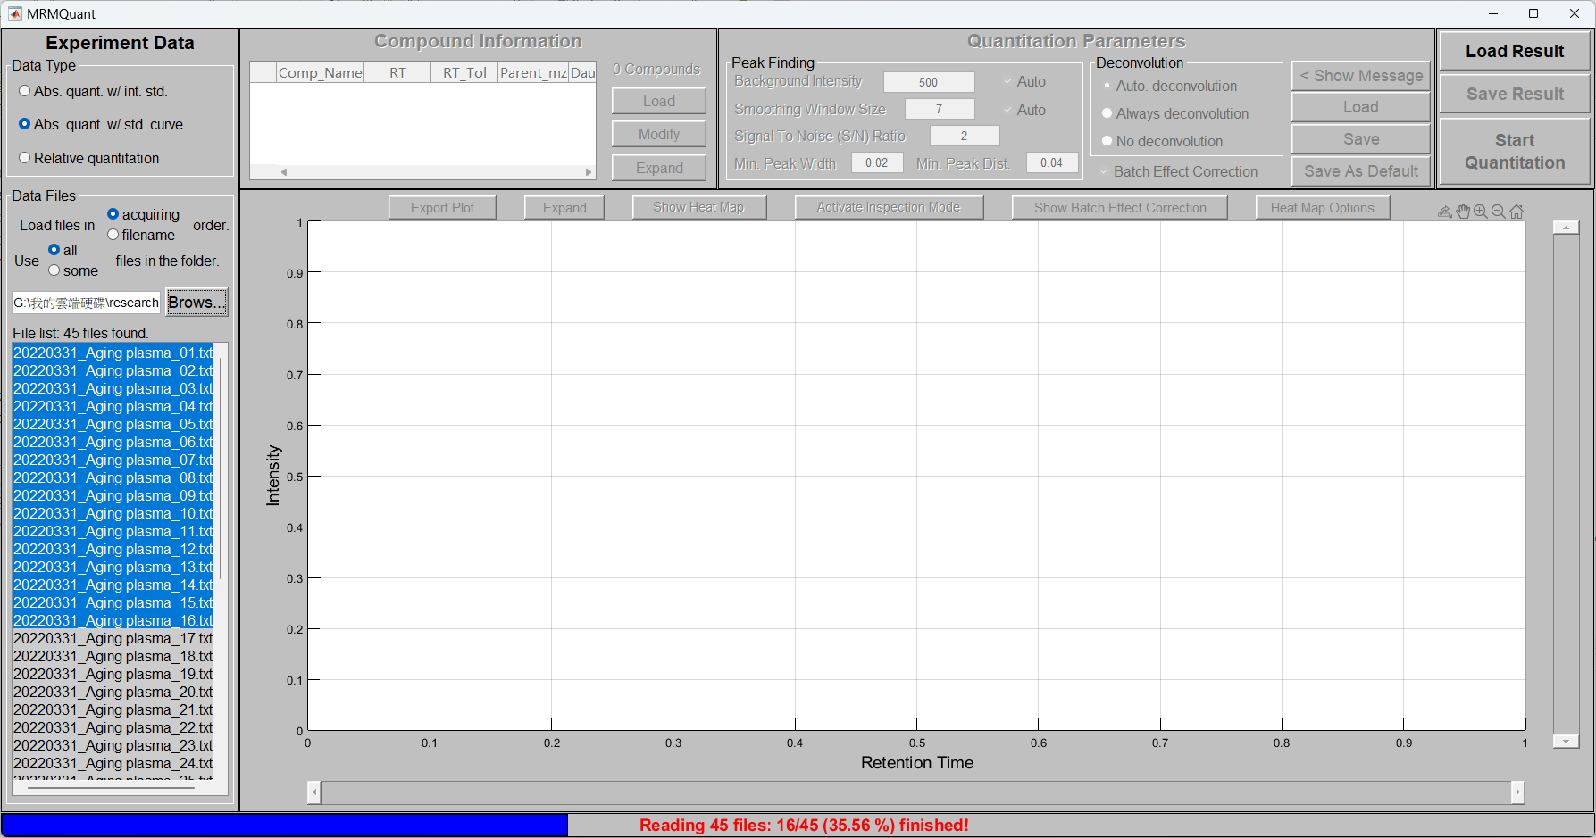

Figure 5. The progress bar at the window bottom reveals the file loading progress

**Load/Modify compound information:** Once the sample files are completely loaded into the system, the "Compound Information" panel will be activated. Press in “Load” button (as shown in Figure 6) to import the method files (in .csv file format) containing the targeted compound information. The required information for the two types of absolute quantitation are shown in Figure 7(a) and 7(b). For relative quantitation, the required columns are the first five columns in Figure 7(a). Noted that the MRMQuant allows multiple compounds in an ion chromatogram. However, compound names should be concatenated with "\_" and RTs should be concatenated with ";" in the method file, as shown in Figure 7(b). The example method files can also be found in <https://github/MRMQuant/test_datasets>.

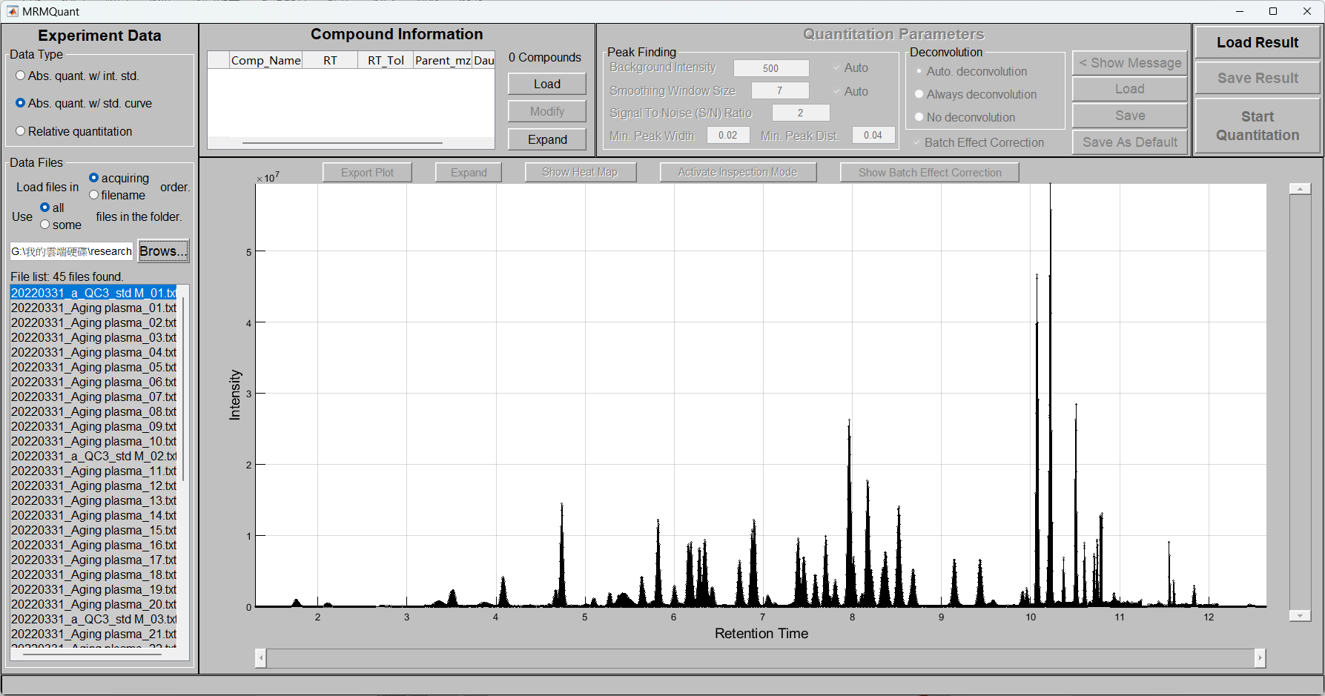

Figure 6. The “Compound Information” panel for MRM method import and modification

|  |
| --- |
|  |
|  |
| (a) |
|  |
|  |
| (b) |

Figure 7. Required columns in the method file. (a) Method file columns for absolute quantitation with internal standards. (b) Method file columns for absolute quantitation with standard curves.

Upon loaded, the compound names and their corresponding RT will be noted in the TIC, as shown in Figure 8. Users can modify the content of the MRM method file by clicking on the "Modify" button beneath the "Load" button. A new window consisting of an editable table will appear (Figure 9(a)). Each cell in the table can be modified. If a fixed RT difference is to be used, input the number in the top entry, press enter, and all the RT tolerances in the table will be changed simultaneously. When all the modifications are done, click on the "Ok" button at the bottom of the window to apply all modifications in the subsequent computations. Users can also click on the "Expand" button to enlarge the compound information panel to display more information in the window, as shown in Figure 9(b). After inspection, users can click on the “Shrink” button to resume to the original window.

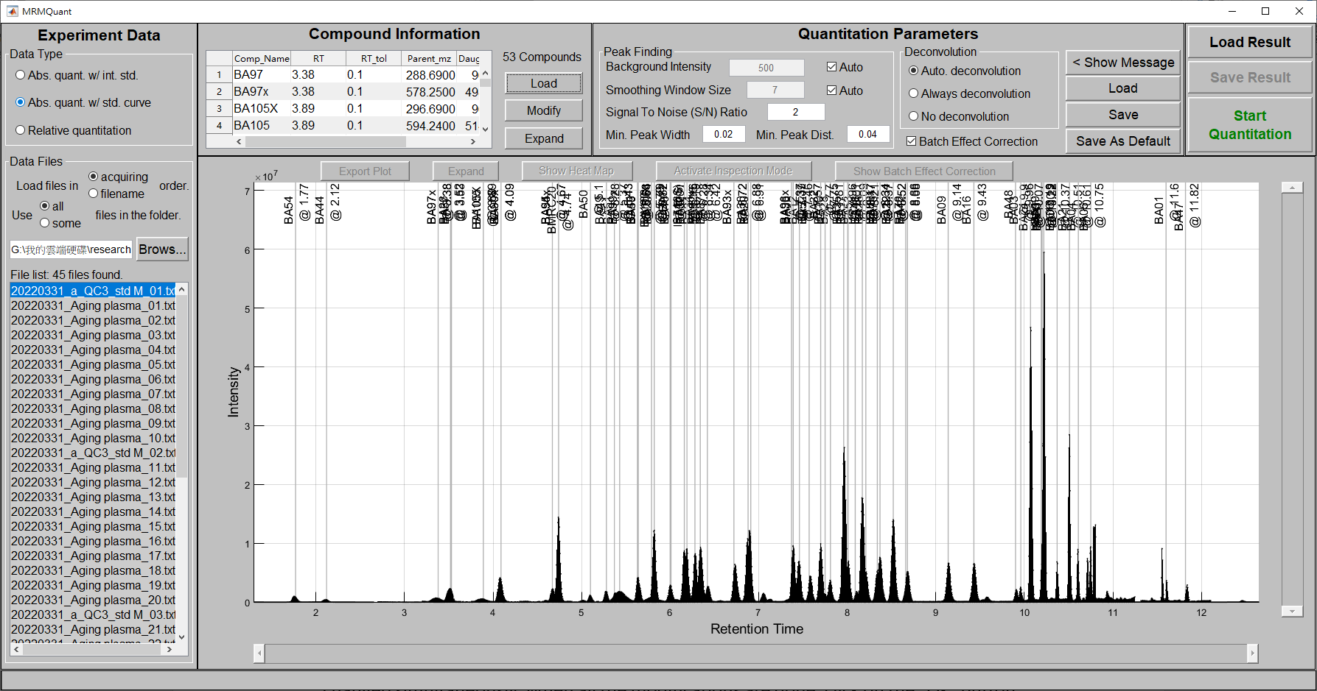

Figure 8. The TIC plot is noted with compound names and their corresponding retention times after the method file is loaded.

|  |  |
| --- | --- |
|  |  |
| (a) | (b) |

Figure 9. Pup-up windows for the compound information. (a) The editable window when the “Modify” button is pressed. (b) The window when the “Expand” button is pressed.

1. **Adjust quantitation parameters**: After the method file is loaded, the "Quantitation Parameters" panel will be activated, as shown in Figure 10. Parameters related to three major tasks in quantitation, including peak finding, deconvolution, and batch effect correction, are to be determined. For peak finding, users can adjust parameters such as background intensity (click on "auto" if it is to be determined by the system's build-in method), signal-to-noise (S/N) ratio, and the minimum peak width and minimum peak distance for coelution determination. For deconvolution, users can select automatic deconvolution, always deconvolution, or no deconvolution when a coeluted peak related to the targeted compound is found. Finally, users should determine whether to perform batch effect correction or not based on whether multiple batches of samples are used and whether QC samples are included in each batch. After modification of the parameters, uses can choose to save the modifications as a file for future use by clicking on the "Save" button at the bottom. The modifications can also be saved as default settings by clicking on the "Save As Default" button so they will be used when the system starts. Users can also click on the "Load" button to use previously saved parameters.

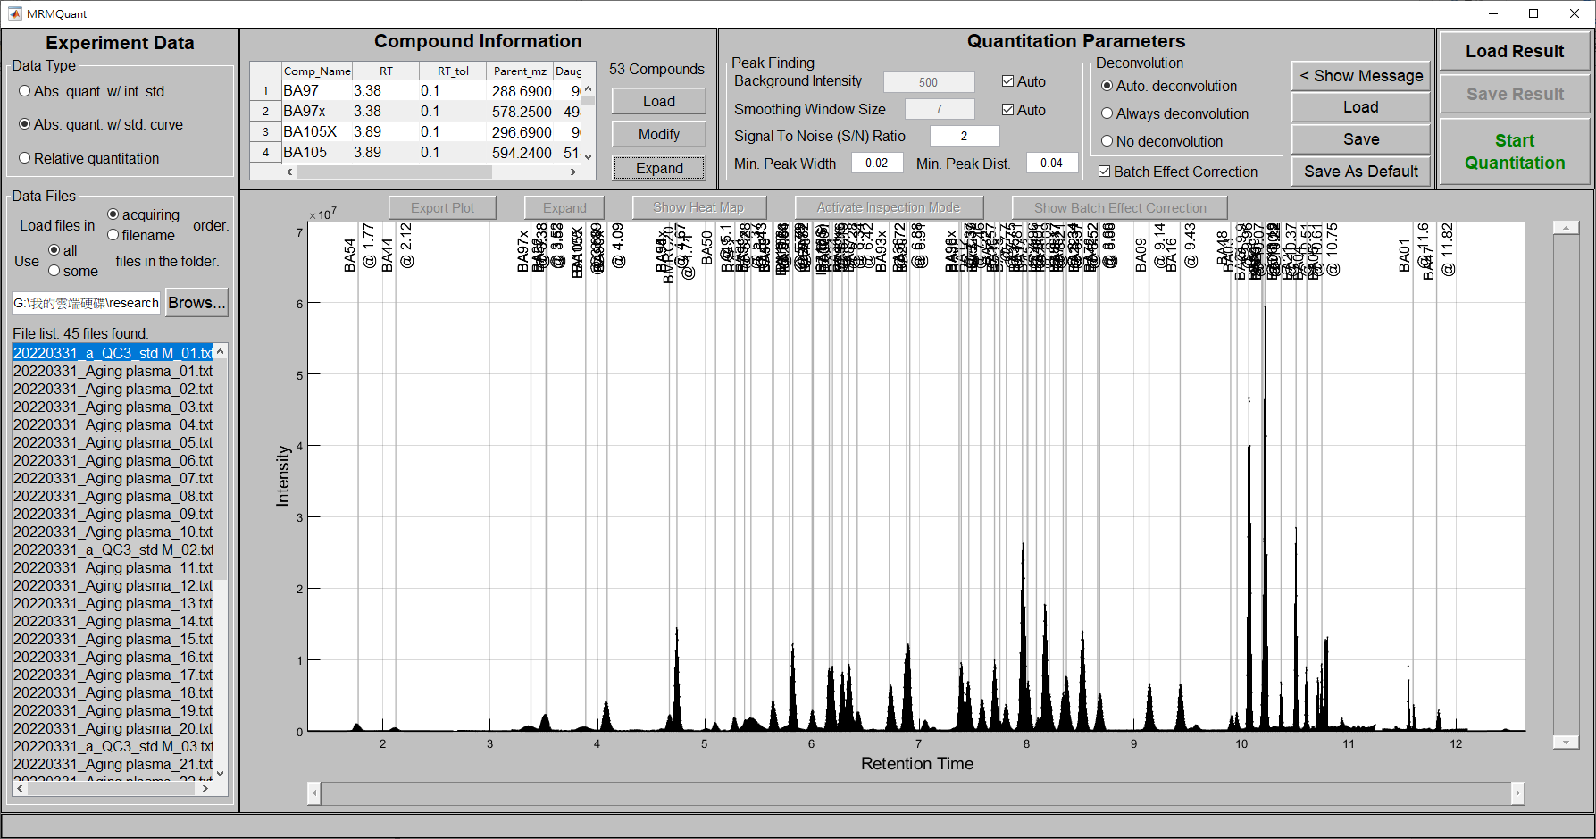

Figure 10. The “Quantitation Parameters” panel for users to adjust parameters at different stages of quantitation

1. **Start the quantitation:** Once all the parameters are assigned, users can click on the green “Start Quantitation” button on the left of the "Quantitation Parameters" panel, as indicated by the red block in Figure 10. During the quantitation process, the TIC plot will change to a heatmap showing the quantitation result. The heatmap will be updated once the quantitation is finished for a sample file. In addition, the corresponding sample file in the Data File section will be marked in blue and a progress bar will be shown at the bottom of the window, as shown in Figure 11. Also, the green “Start Quantitation” button will turn red and show “Stop quantitation” during the quantitation process. The user can stop the process by click on the button and the process will be stopped when the quantitation is finished for the current sample.

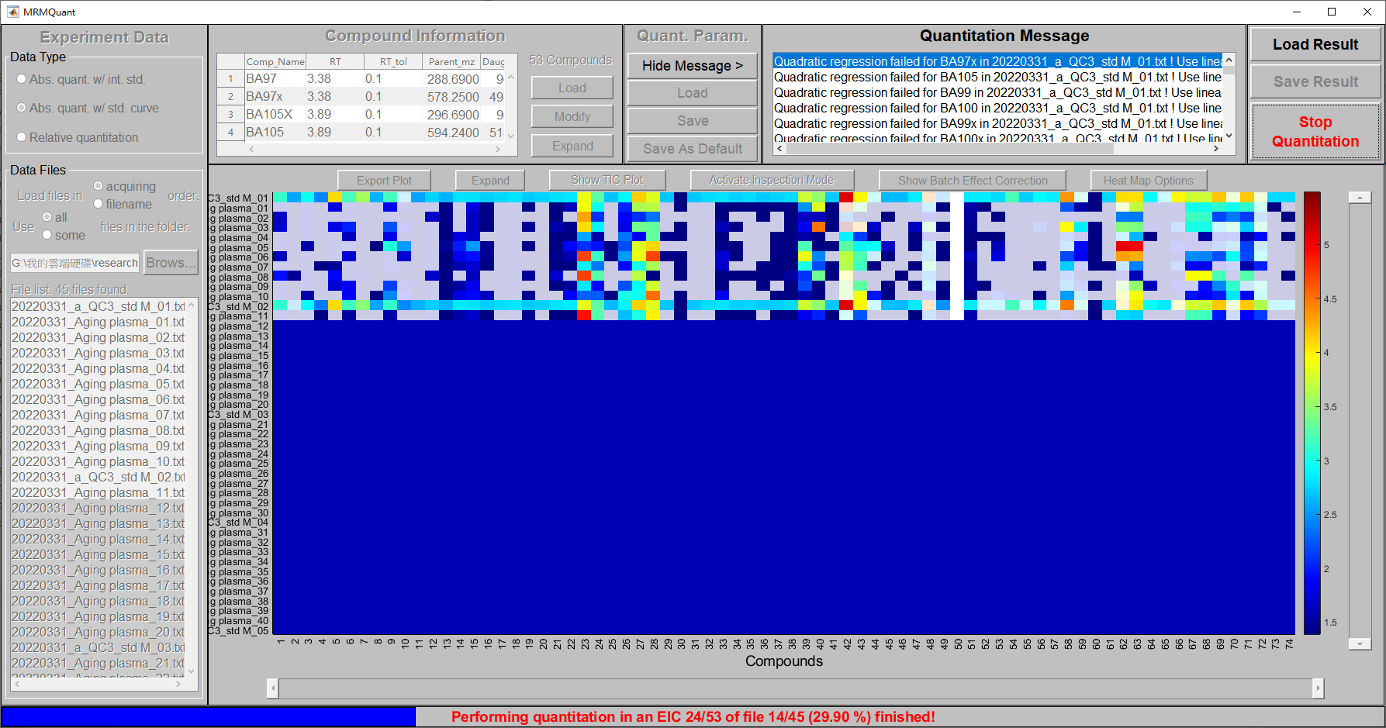

Figure 11. The heatmap and the progress bar during the quantitation process.

Once the entire quantitation process is finished, the heatmap will be rearranged to a pre-specified range. The default range is 10 samples (in vertical direction) and 50 compounds (in the horizontal direction) specified in the default\_parameter.xlsx. The user can change the display range by clicking on the “Heatmap Option” button (refer to the Heatmap Option section). The user can use the vertical and horizontal scroll bars to change the viewing range. The user can also check the quantitation result of a cell in the heatmap including abundance, concentration (conc\_org), normalized concentration(conc\_norm), and quantitation status by moving the mouse cursor over the cell, as shown in the bottom middle of Figure 12. The color of the cells in the heatmap represents the concentration of the corresponding compound for the data type of absolute quantitation and the abundance of the compound for the data type of relative quantitation. The abundance is obtained by the trapezoidal integration of the peak area, where as the concentration is obtained by a further conversion of the abundance via an internal standard in the sample or via a standard curve. Moreover, the color is displayed in the logarithm scale by default. It can be change to its original scale via the “Heatmap Option” button. The magnitude of the computed value can be referred to the color bar showing at the right of the heatmap. Furthermore, for each inspection, according to the quantitation status, the color of a cell is masked with 20% transparent grey if its quantitation status is “no qualified peak” or “multiple possible peaks” to indicate minor problems and is painted in white if the status is “saturated signals”, “defect quantitation”, or “concentration unconvertable” to denote problems that deserve more attention. Such a mask can be removed by changing the setting in the “Heatmap Option”. Other than the above settings, the color scheme and the grid line of the heatmap can also be changed vis the “Heatmap Option” button.

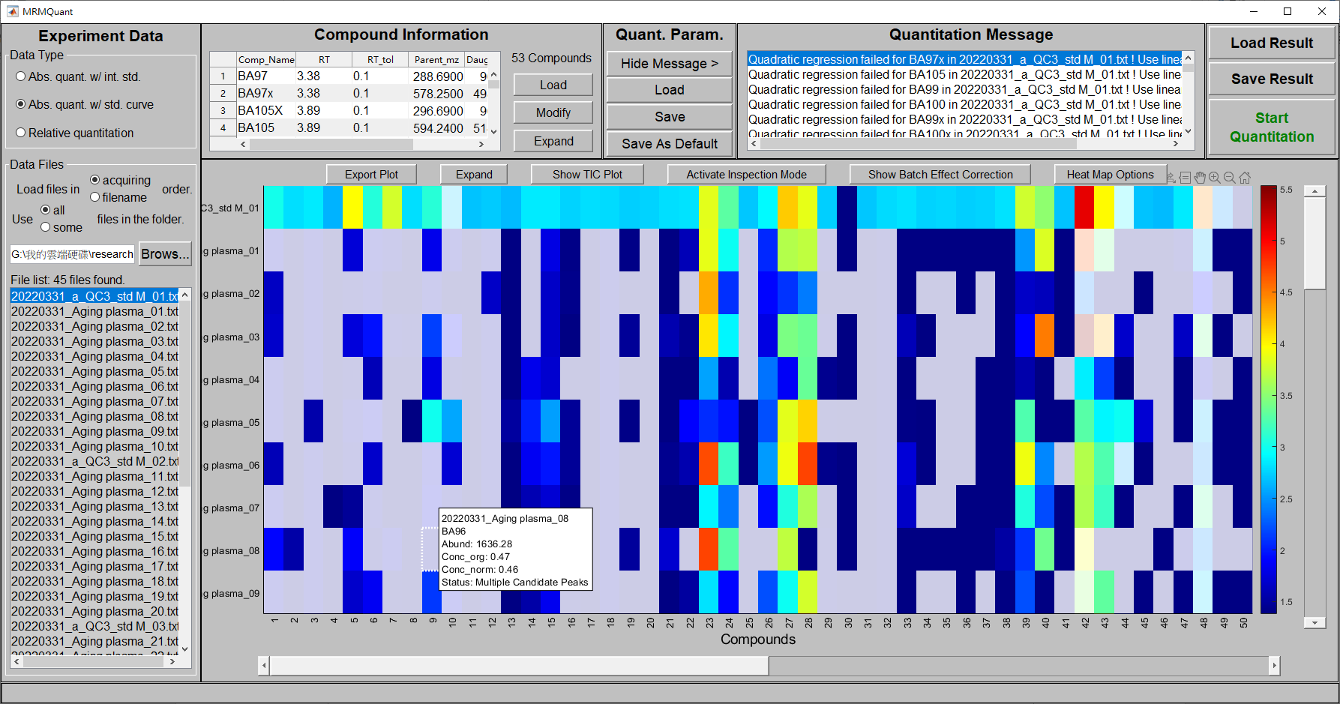

Figure 12. The 10-sample×50-compound heatmap after the quantitation is finished.

On the top of the heatmap, there are five buttons named “Export Plot”, “Expand”, “Show TIC Plot”, “Activate Inspection Mode”, "Show Batch Effect Correction", and “Heatmap Options”. The first two buttons are used to ex-port and to expand the plot to full window, respectively. The third button is used to switch between TIC and heatmap in the panel. The fourth button activates/deactivates the inspection mode to enable/disable the Multiple Reaction Monitoring window to popup once a heatmap cell is clicked. The fifth button allows users to check the effectiveness of the batch effect correction and the last button is used to change the appearance of the heatmap. The details of the five buttons will be introduced in the following sections.

1. **Export the heatmap plot:** The quantitation heatmap can be exported to an image file by pressing the “Export Plot” button on the top of the heatmap. A window will pop up to let the user to adjust the size of the image, as shown in Figure 13(a). By clicking on the Rending in the left panel, the user can also select the color space, background color, renderer, and resolution, as shown in Figure 13(b). By clicking on the Fonts in the left panel, the user can change the font properties in the plot, as shown in Figure 13(c). By clicking on the Lines in the left panel, the user can also change the font properties in the plot, as shown in Figure 13(d). After the all the changes are made, the user can click on the “Export” button in the righthand side, a new window will appear to select the folder and file name of the output image as well as the image format, as shown in Figure 13(e). The supported image formats are listed in Figure13(f).

|  |  |
| --- | --- |
|  |  |
| (a) | (b) |
|  |  |
| (c) | (d) |
|  |  |
| (e) | (f) |

Figure 13. The windows to export the heatmap image.

1. **Expand/shrink and show the heatmap/TIC plot:** To better reveal the contents in the heatmap, the user can press the “Expand” button on the top of the heatmap, as shown in Figure 14. Similarly, a TIC plot can be also enlarged using this function. Alternatively, an enlarged TIC plot can be obtained using the “Show TIC plot” button on the top of the heatmap, as shown in Figure 15. The “Show TIC plot” button on the top of the heatmap will be renamed to “Show Heatmap” once the TIC plot is in display, and vice versa. On the other hand, the expanded plot can be resumed to its original size by pressing the “Shrink” button on the top of the plot.

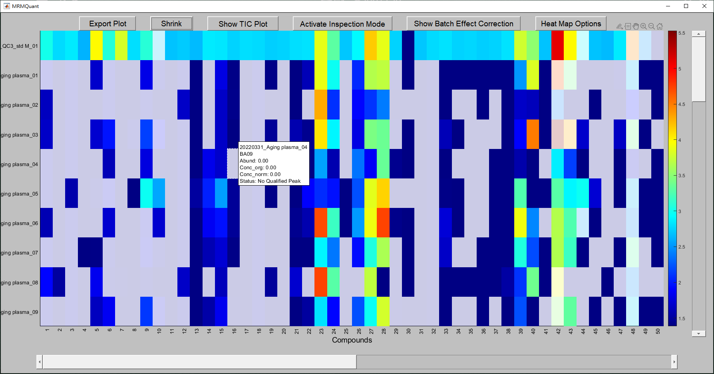

Figure 14. The expanded heatmap after the user presses the “Expand” button on the top of the heatmap. The “Expand” button will be renamed to “Shrink” once the expansion is done. The user can use the “Shrink” button to resume the plot to its original size.

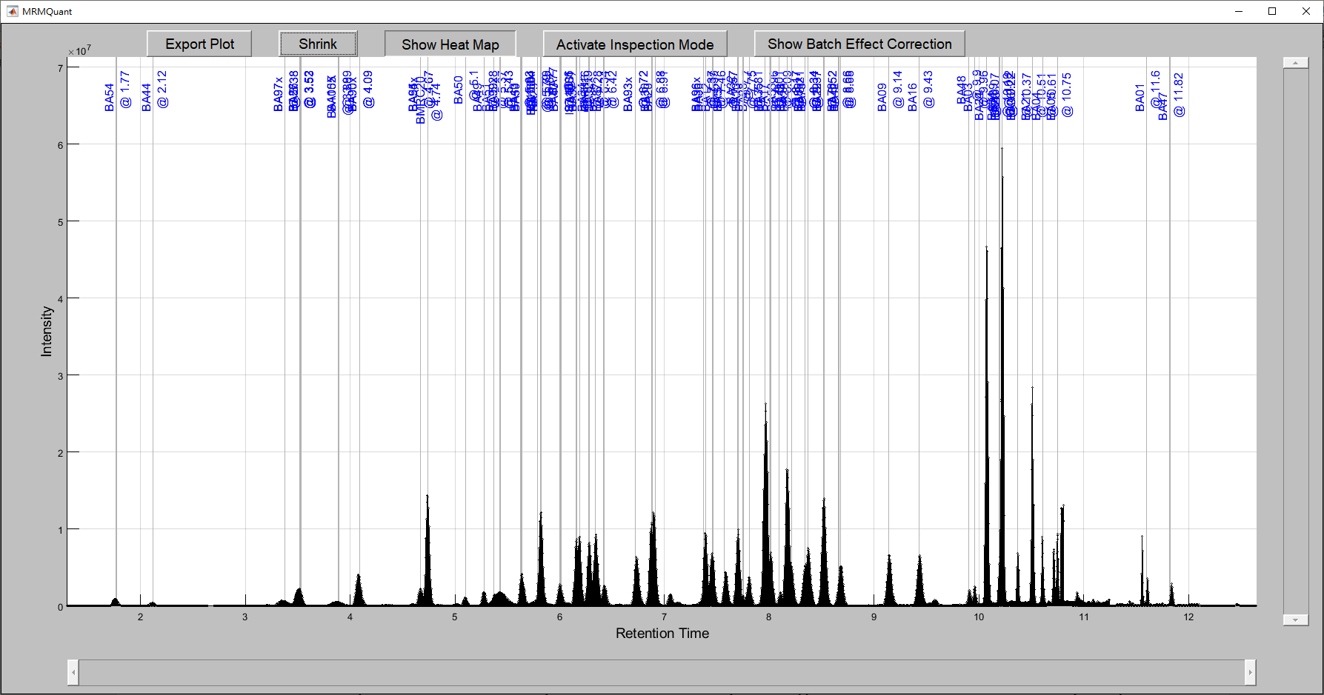

Figure 15. The expanded TIC plot of the current sample file (the highlighted file in the ‘Data File’ list). The user can use the “Shrink” button to resume to its original size or use the “Show Heatmap” button to change the display to heatmap.

1. **Activate/deactivate inspection mode:** In addition to checking the computed abundance/concentration and quantitation status by moving the mouse cursor over a heap map cell, the user can further inspect the detailed quantitation result of an ion chromatogram by activating the inspection mode using the “Activate Inspection Mode” button. Once the button is pressed, the text of the button becomes “Deactivate Inspection Mode” indicating the inspection mode is activated and the use can click on a heap map cell to inspect the quantitation details of the corresponding compound. As shown in Figure 16, when the inspection mode is activated and the cell in heat map or the compound name in TIC corresponding to the compound “BA42” in the sample “20220331\_Aginf\_plasma\_05” is clicked, the Multiple Reaction Monitoring window will appear showing the corresponding ion chromatogram.

|  |
| --- |
|  |
| (a) |
|  |
| (b) |

Figure 16. As the inspection model is activated, clicking on (a) a cell in the heap map or (b) a compound name in the TIC will bring up a window showing the quantitation details in the corresponding ion chromatogram.

The user can utilize the “Multiple Reaction Monitoring” window to navigate, inspect, correct, and to export the detailed quantitation result of a single ion chromatogram. There are three ways to bring up the window: (1) by clicking on a cell in the heatmap, (2) by clicking a compound name in a TIC plot, and (3) by clicking on one of the ion chromatograms in the standard curve window (refer to the Standard curve generation section). An example of the Multiple Reaction Monitoring window is demonstrated in Figure 17. Panel (a) in the figure shows the ion chromatogram of the selected MRM and compound. Colored lines and regions represent different information, for instance, black curve for the profile of the smoothed signals, gray blocks for the RT tolerances of the targeted compounds, vertical black, red, green, and blue lines for original signals, detected peak tip, detected compound peak, and deconvoluted peak, respectively. As shown in the panel, MRMQuant can deal with multiple compounds in a chromatogram by automatically decomposing the coeluted peaks for better abundance estimation.

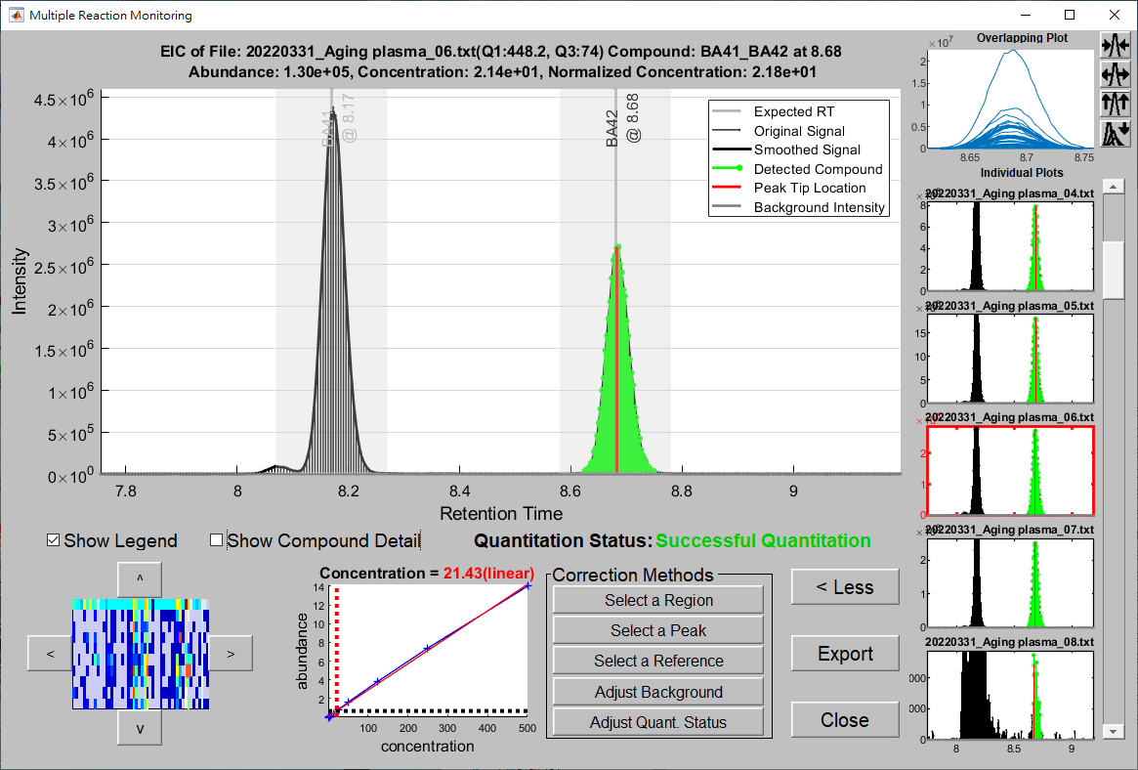Figure 17. The Multiple Reaction Monitoring window. Panel (a) shows the original signals and the detected peak for the targeted compound in the selected MRM file. Panel (b) contains buttons corresponding to navigation, inspection, correction, and export functions. Panel (c) shows overlapped and individual detected peaks of the targeted compound in different sample files.

b

c

a

Panel (b) in the figure exhibits buttons to navigate, inspect, correct, and export the peaks in the ion chromatogram. On the top, there are two checkboxes to show/hide the legend in the panel(a) and to show compound detail by displaying the zoom-in plot of the quantitated peak in the ion chromatogram (as showed in Figure 18) and a text message to show the quantitation status of the compound. On the left, a mini-heatmap with four arrow buttons allows users to browse nearby compounds. On the right to the mini-heatmap, a plot shows the standard curve (the red solid line) of the current compound for the conversion of concentration (the red dotted line) from abundance (the black dotted line) of the current compound and its associated internal standard for the absolute quantitation experiment. On the right to the standard curve plot, there are five buttons designed to correct the quantitation by specifying (1) a peak region, (2) a peak tip, (3) a reference sample, (4) the background intensities, and (5) the quantitation status. Pressing on the “Select a Region” button, the mouse cursor will turn into a “🞣” sign and the user can then click, hold, and drag a rectangle using the mouse containing the expected peak, as shown in Figure 19. The MRMQuant will determine the possible peak signals from the signals around the rectangle by looking for the local minima on the both sides as the left- and right-boundaries and the local maximum as the peak tip and integrate the signals between the two boundaries as the abundance of the peak, as shown in Figure 20.

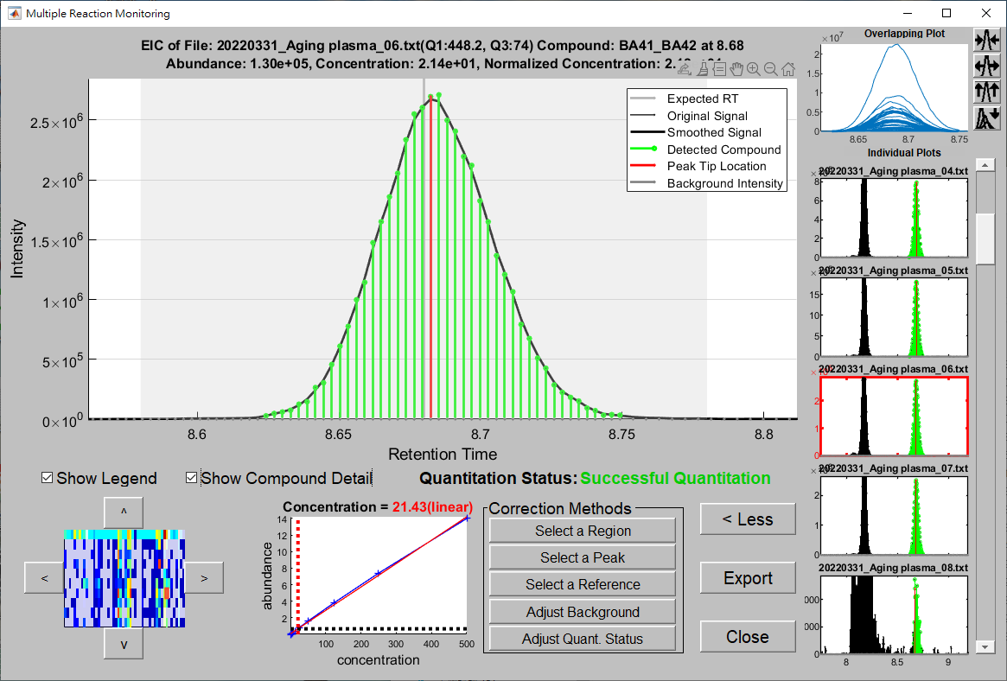

Figure 18. The zoom-in plot of the quantitated compound in the ion chromatogram.

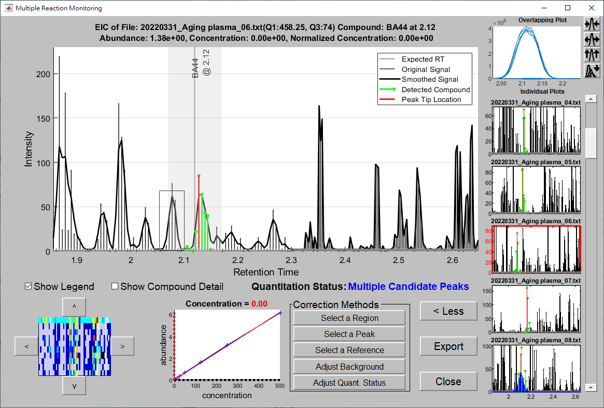

Use the mouse to click, hold, and drag a rectangle whose left and right bounds contain correspondingly the left and right bounds of the expected peak.

Figure 19. The expected peak region specified by the rectangle created by clicking and dragging the mouse cursor after pressing on the “Select a Region” button.

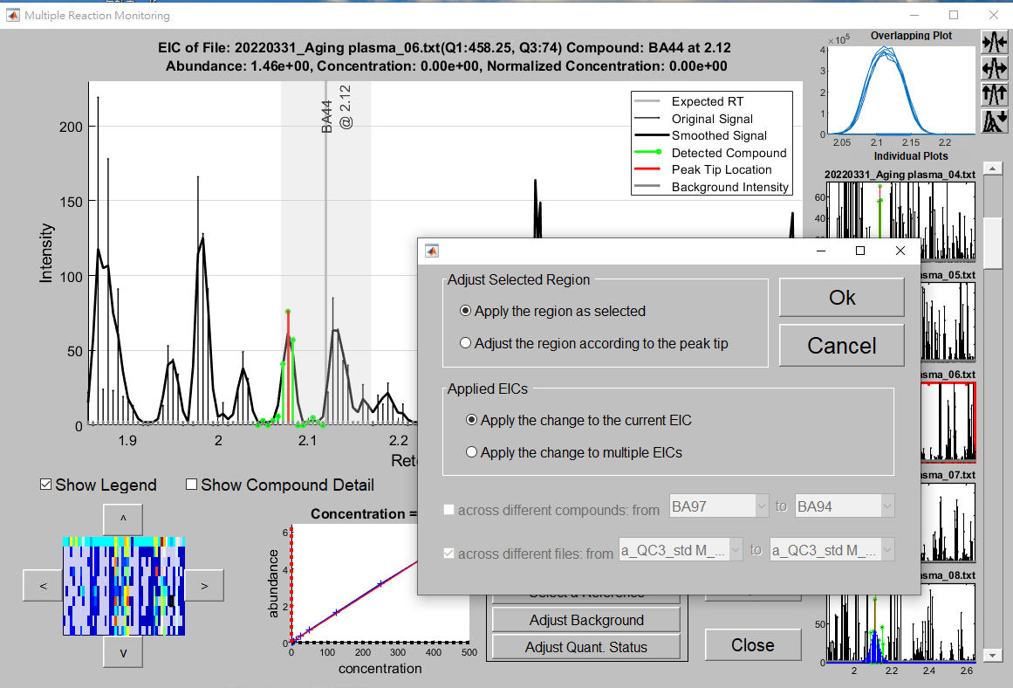

Figure 20. The new peak determined by the “Select a Region” method and the window for the user to choose whether to apply the similar change to the same compound in other samples and which samples to be applied.

At the same time as the peak area is updated, a window will appear for the user to select (1) whether the similar modification is applied to other samples, (2) whether the boundaries in other samples are defined by the same boundaries as in the current sample or by the peak tip in the corresponding sample using the same peak width, (3) the consecutive compounds where the same modification is to be applied, and (4) the consecutive samples where the same modification is to be applied, as shown in Figure 21. Figure 22 shows the modification in Figure 20 is applied to all samples.

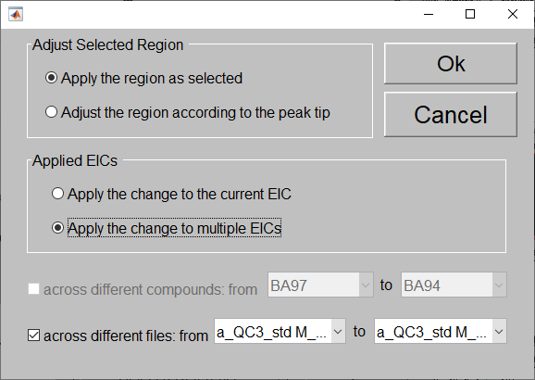

Figure 21. The window for the user to specify how, which samples, and which compounds the modification is to be applied.

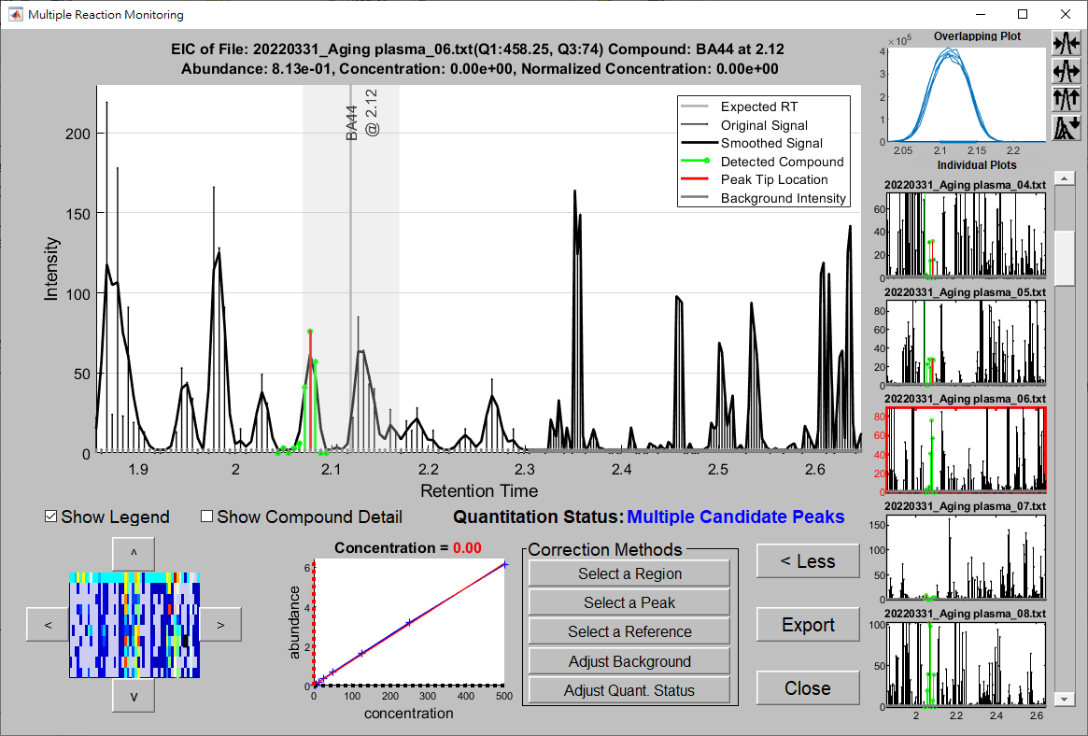

Figure 22. The change of quantitation result when the modification is applied to the same compound in all samples. As shown in the right panel, the peak areas for the compound BA44 in different samples share the same RT range, as requested in Figure 21.

If the peak shape of the targeted compound is smooth and clean but was misidentified by the program, probably due to smaller intensity or farther distance from the expected RT than other peaks in the RT tolerance. In these cases, the user can use the “Select a Peak” button. Once the button is pressed, the mouse cursor will turn into a long cross and the user simply needs to click on the neighborhood of the peak tip to change the peak to the correct one, as shown in Figure 23. Once the new peak is successfully recognized, the peak is annotated by the colors specified in the legend and a window will appear to allow the user to determine whether the same modification should be applied to multiple samples, as shown in Figure 24.

To further simplify the modification process, MRMQuant provides a “Select by Reference” button for simultaneously modify multiple compounds and multiple samples. This function requires a reference sample for each batch, as shown in Figure 25. The reference is recommended to be selected from QC samples or samples whose compounds are mostly abundant and inspected so that its compound boundaries can be used to find the possible peaks in the other sample.

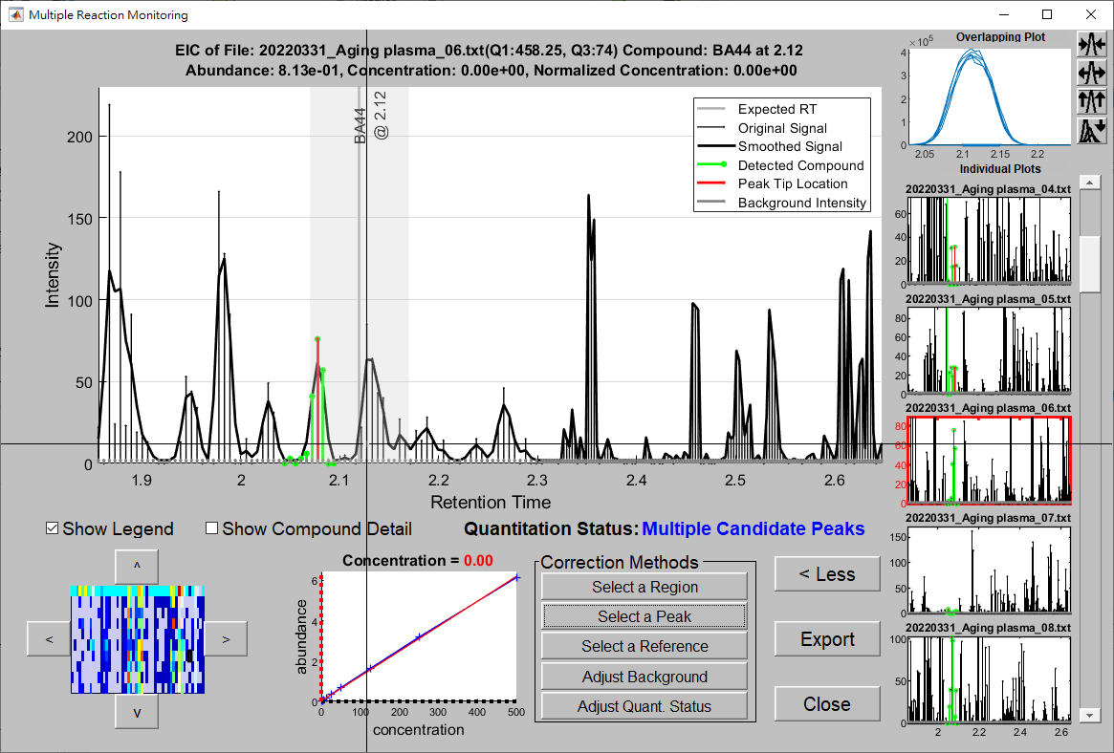

Figure 23. Change of peak corresponding to the targeted compound using the “Select a Peak” function.

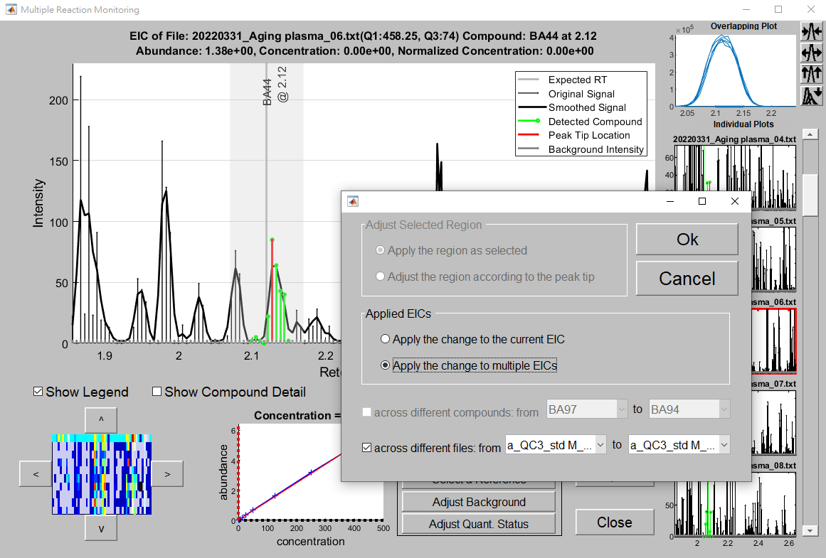

Figure 24. The new peak determined by the “Select a Peak” method and the window for the user to choose whether to apply the similar change to the same compound in other samples and which samples to be applied.

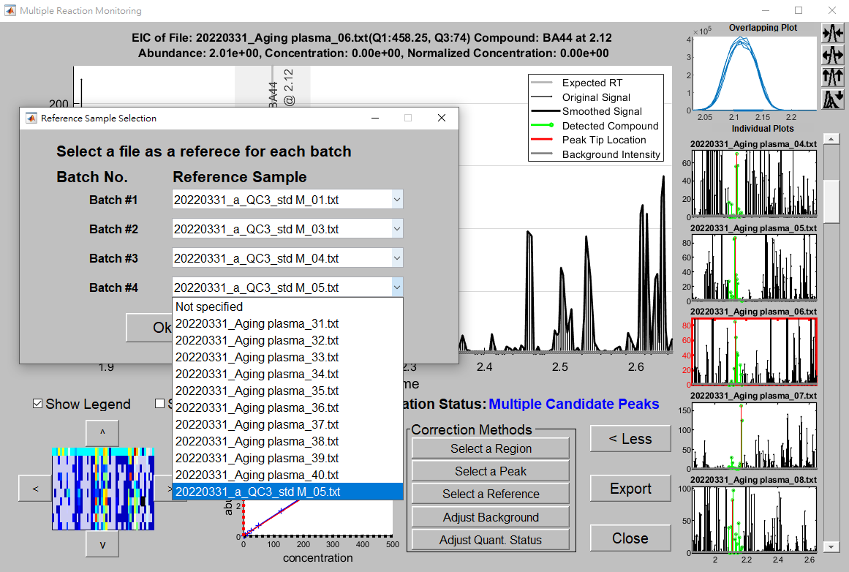

Figure 25. The “Select a Reference” function allow the user to assign a reference for each batch so that the peaks for the targeted compounds in other samples can be quantitated based on the conditions in the reference.

For an ion chromatogram whose background intensities exhibit considerable fluctuations, the constant intensity assumption in MRMQuant may not accurately reflect the profile of the background intensities under the peak area causing errors in the subsequent peak quantitation. To deal with such a situation, the user can utilize the “Adjust Background” button to indicate the correct intensities. Similar to the “Select a Peak” method, once the user presses the “Adjust Background” button, the cursor will turn into a long cross and the user needs to use a series of left click on the correct background intensities under the peak area and a right click to terminate the process, as shown in Figure 26. The peak abundance and concentration will be recalculated based on the new background intensities, as shown in Figure 27. In addition, the changes in the background intensity can be applied to multiple compounds and/or multiple samples, as shown in Figure 28.

Finally, the user can assign the quantitation status to “Successful Quantitation” using the “Adjust Quant. Status” button. Once the button is pressed, a window will appear to let the user determine whether the similar change should be applied to other samples, as shown in Figure 29.

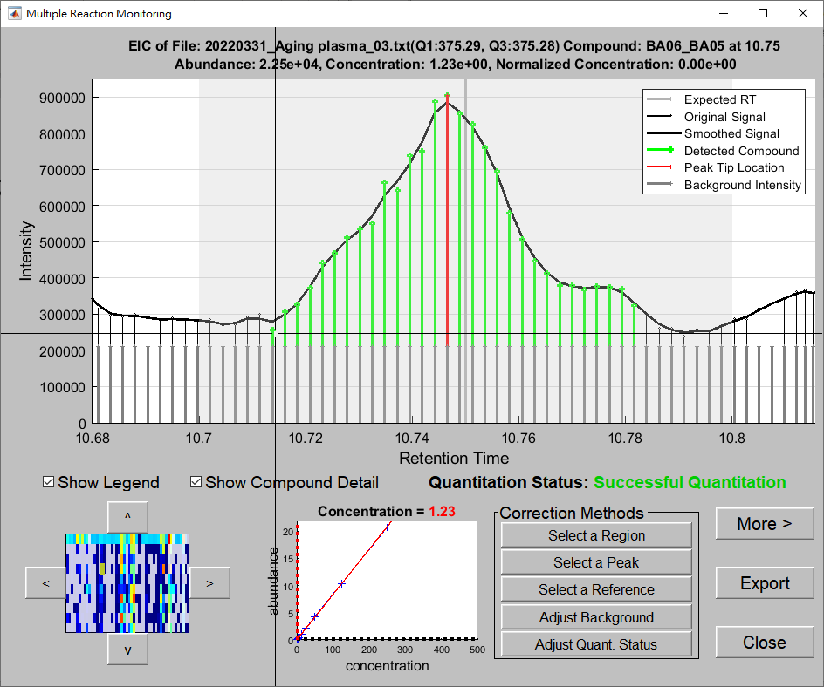

4.right click

3.left click

2.left click

1.left click

Figure 26. User specified background intensities using the “Adjust Background” method. After activate the “Adjust Background” method, the user specifies 4 points via 3 left clicks and one right clicks (indicating the termination of the process) for the new background intensities. The MRMQuant will use the new background intensities for the peak quantitation.

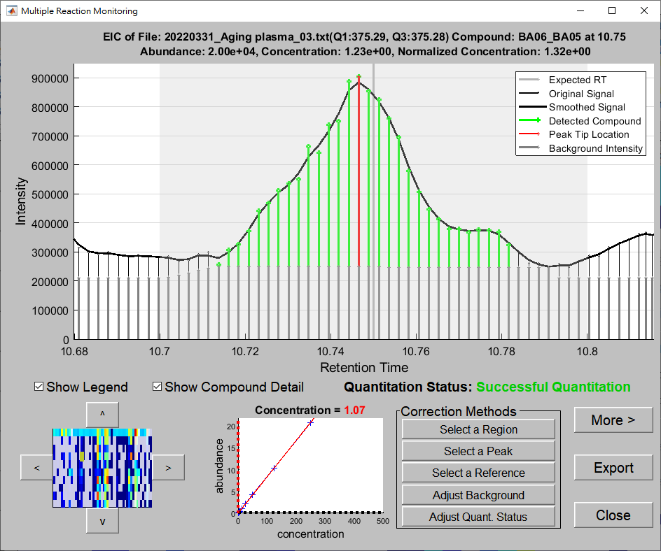

Additional background intensities

Figure 27. The smaller peak area due to higher background intensities specified by the user.

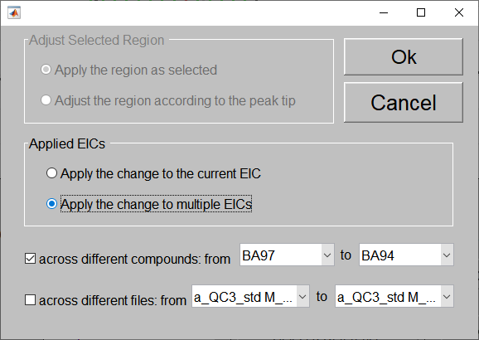

Figure 28. The changes in the background intensity can be applied to multiple compounds and/or multiple samples

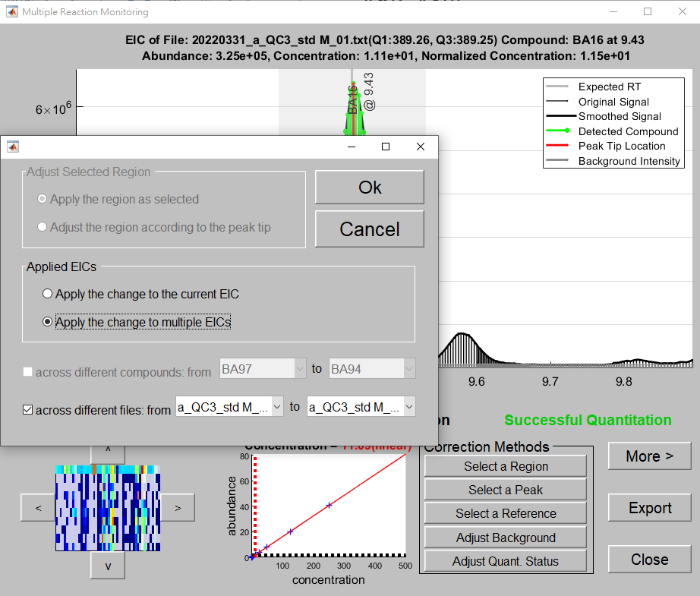

Figure 29. The “Adjust Quant. Status” changes the quantitation status of the current ion chromatogram to “Successful Quantitation”. Such a change can be applied to the same compound of multiple samples using options in the pup-up window.

There are three more buttons at the right-hand side of the correction methods. The “More >” button is used to show the same compound found in the other ion chromatograms. Once pressed, the text of the button will be changed to “Less <” and an additional panel (panel (c) in Figure 17) will appear to show such plots, as shown in Figure 30. This panel shows the overlapped peaks (zoomed-in horizontally) of all sample files at the top and the detected peak in individual file below for easy inspection of the same compound across sample files. The plot of overlapped peaks is useful in checking the consistency of the compound across all the sample files. To remove the panel, the user can press the “Less <” button. The user can further use the four buttons next to the overlapped plot to zoom out the peaks horizontally to the original RT range, to zoom in the peaks horizontally to the detected peaks only, to normalize the peak heights, and to resume the original heights, as shown in Figure 31. The “Export” button is used to export the ion chromatogram to an image file. Similar to the export of heatmap, once the button is pressed, a window will appear to let the user to choose rendering methods, line width, font type and size, resolution, image format, and file name of the image (refer to Figure 13 for details). Finally, the “Close” button is used to close the “Multiple Reaction Monitoring” window.

|  |  |
| --- | --- |
|  |  |
| (a) | (b) |
| |  |  |  |  | | --- | --- | --- | --- | |  |  |  |  | | (c) | (d) | (e) | (f) | | |

Figure 31. The additional panel that display the detected peak of a compound in different samples and an overlapped plot of the detected peaks in all the samples. (a) The “More >” button that bring out the panel. (b) The “Less <” button that close the panel. (c) The four buttons that control the appearance of the overlapped peaks: horizontal resume, horizontal zoom-in, vertical normalization, and vertical resume. (d) Use the horizontal resume button to resume the detected peaks to their original scale. (e) Use the vertical normalization button to normalize the peak heights of all the detected peaks to 1.0. (f) Use the horizontal zoom-in button to expand the detected peaks horizontally to the same tight RT range in order to check for the RT differences among the peaks.

1. **Show batch effect correction:** MRMQuant provides the batch effect correction function for MRM sample data contains multiple batches. To invoke such a correction, the user needs to check the “Batch Effect Correction” option in the “Quantitation Parameter” panel, as shown in Figure 32. In MRMQuant, we adopted the quality control–based robust LOESS (locally estimated scatterplot smoothing) signal correction (QC-RLSC) algorithm published by Dunn et al. and The Human Serum Metabolome (HUSERMET) Consortium. In short, for each compound, the following four steps are performed for batch effect correction. Step 1. Trend Estimation: a LOESS curve is fitted to its abundance in the QC samples. Step 2. Interpolation: the corrected abundances of the compound in other samples are estimated using cubic-spline interpolation/extrapolation of the LOESS curve (all the samples should be arranged in their analytical order). Step 3. Trend Removal: The ratios between the abundances computed from the ion chromatograms and those from the LOESS curve are calculated. Step 4: Magnitude Restoration: After trend removal, the LOESS curve becomes a flat horizontal line with intercept 1, and thus the abundances are restored by multiplying the ratios by the median abundance of the QC sample. For absolute quantitation, the conversion from abundances to concentration is performed after the batch effect correction via internal standards or standard curves.



Figure 32. Check the “Batch Effect Correction” option in the “Quantitation Parameter” panel to invoke the batch effect correction function during the quantitation process.

If the “Batch Effect Correction” option is chosen, the “Batch Effect Correction” window will appear before the quantitation process. In the window, there is a table containing a list of all the samples with three columns of checkboxes namely, QC sample, Reference, and Batch End, as shown in Figure 33. Firstly, the user needs to specify the QC samples by checking their corresponding checkbox in the table. To simplify this task, the user can input the unique term for the QC samples (for example, “QC” in Figure 33) in the entry at the upper right corner to let the MRMQuant to do it automatically, as shown in Figure 33. Secondly, the user can select a reference sample for each of the batch. The reference is used for the magnitude restoration. However, this step is optional and the MRMQuant will use the median abundance of samples in a batch if no reference is selected in the batch. Finally, the user need to indicate the last sample in each batch in the “Batch End” column and MRMQuant will automatically assign a batch number to each sample based on the indication. In addition, the user needs to specify the window size called “regression span” for the LOESS smoothing kernel. If value of the regression span is greater than 1, the window size is set to the number of QC samples. The minimum number for the span is 3. Higher values will smooth the signal more at the expense of computation time. If value of the regression span is less than 1, the window size is taken to be a fraction of the number of QC samples in the data. For example, when the value is 0.1, the window size is equal to 10% of the number of QC samples in the data.

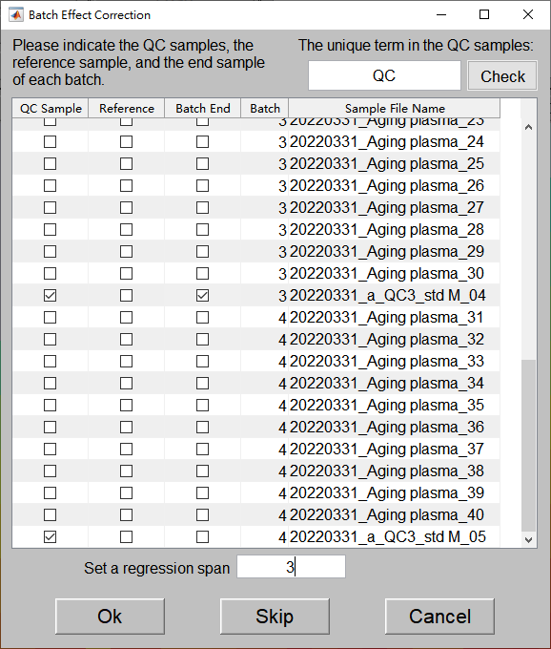

Figure 33. The “Batch Effect Correction” window for the user to input batch-related information.

After the quantitation process is finished, the user can press the “Show Batch Effect Correction” button above the heatmap to inspect the effectiveness of the batch effect correction, as shown in Figure 34. Once the button is pressed, a “Batch Effect Correction” window will appear to show the concentrations of a target compound before and after the correction is made, as shown in Figure 35. In this figure, the original concentrations of the targeted compound BA100 across sample files and their concentrations after batch effect correction. As shown in the figure, the regression line of the compound concentration in the QC samples exhibit a slightly decreasing trend (slope = -0.0712) in the original data. However, such trend was eliminated and the regression line was leveled out (slope = -0.0060) after the batch effect correction. In addition, the R2 value was reduced from 0.57 to 0.037 indicating the diminishing of fluctuation in the corrected concentrations.

At the top of the figure, there are functions for the user to change the plots. First, the use can change the displayed compound in the plot by selecting another compound name in the dropdown menu. Moreover, to reveal differences in small values or to subpress them in high values, the user can press the “Log Transform” button to change the concentration value from linear to logarithmic scale. In addition, if the user is not satisfied about the correction result, he/she can use the “Rerun” button to run the batch effect correction with different parameters. Furthermore, the user can use the “v More” button to inspect the concentration trend across samples of a particular internal standard. Similarly, the user can use the “Log Transform” button at the top of the plot to change the concentration value from linear to logarithmic scale.

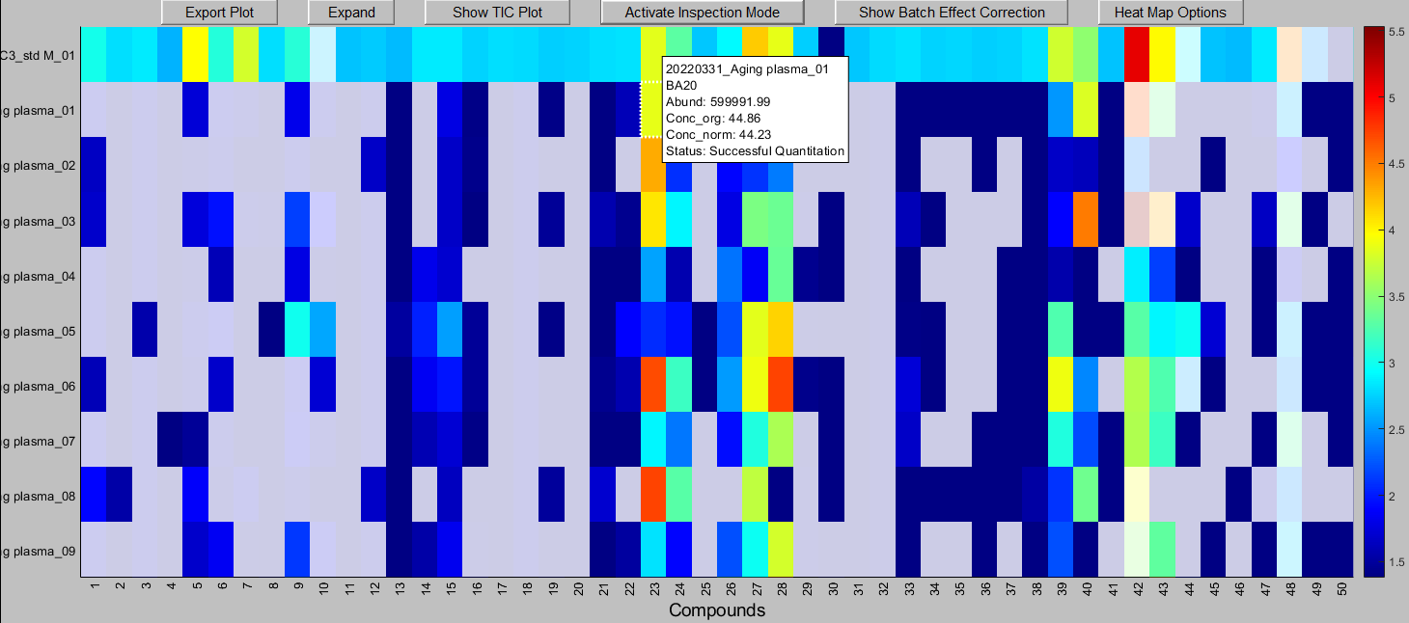

Figure 34. The “Show Batch Effect Correction” button above the heatmap.

|  |  |
| --- | --- |
|  |  |
| (a) | (b) |

Figure 35. The regression lines of the concentrations of the QC samples before and after batch effect correction. (a) The original comparison. (b) The plot of the concentration trend across samples of a particular internal standard is revealed if the “v More” button is pressed.

1. **Heatmap options:** The aspect of the heatmap can be customized by the user using the “Heatmap Option” button, as shown in Figure 36. Figure 36(a) shows the default heatmap, in which the logarithmic concentrations of the first 50 target compounds in the first 10 samples are showed in the heatmap. From Figure 36(b) to Figure 36(g) show accordingly (b) the logarithmic concentrations being replaced by logarithmic abundances, (c) the logarithmic abundances being replaced by the original abundances, (d) the grid lines being added among cells, (e) the color bar indicating the colors in the map and their corresponding values being removed, (f) the masks denoting the problematic cells being removed, (g) the color scheme being changed from “Jet” to “Hot”, and (h) the display range being changed from 10 files and 50 compounds to 20 file and 30 compounds.

|  |  |  |
| --- | --- | --- |
| (a) |  |  |
| (b) |  |  |
| (c) |  |  |
| (d) |  |  |
| (e) |  |  |
| (f) |  |  |
| (g) |  |  |
| (h) |  |  |

Figure 36. The heatmap options and their corresponding effects to the heatmap. (a) The heatmap of the default options (show 50 compound logarithmic concentrations in each of 10 samples with masks for ambiguous quantitations in Jet color scheme). (b) The heatmap after the content is changed from concentrations to abundances. (c) The displayed abundances are changed from logarithmic to linear scale. (d) The grid lines are added to the heatmap. (e) The colorbar indicating the associated values of the colors is removed. (f) The grey masks showing ambiguous quantitations are removed. (g) The color scheme of the heatmap is changed from “jet” to “hot” (with colorbar resumed). (h) The size of the heatmap is changed to 30 compounds in each of the 20 sample files.

1. **Quantitation message:** During the quantitation process, the “Quantitation Parameter” panel will be minimized, the “Show Message <” button will be renamed as “Hide Message >”, and the “Quantitation Message” panel will be revealed, as shown in Figure 37. This message panel is mainly designed to display a message reflecting the encountered problematic quantitation, for example, unsuccessful in peak tracing (saturated peaks, irregular peak shapes), deconvolution, standard curve generation (no suitable quadratic curve), etc. Such messages will also be saved to the output file when the quantitation result is exported. The user can determine whether to correct the quantitation of the corresponding compound using the “Multiple Reaction Monitoring” window, as mentioned in the section 6. The user can press the “Show Message <”/“Hide Message >” button to open/close the message window.



Figure 37. The “Quantitation Message” panel will appear to display a message reflecting the encountered problematic quantitation.

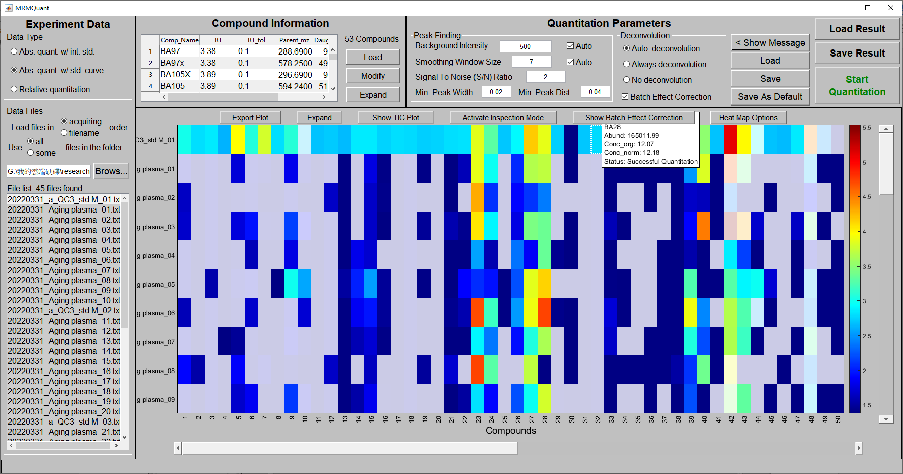

Figure 38. The user can press the “Hide Message >” button to minimize the message window and resume the parameter window.

1. **Standard curve generation:** If the user selected “Abs. Quant. w/ STD. Curve” at the Data Type, after the user clicks on the “Start Quantitation” button, the “Import Standard Curve Files” window will appear for the user to input relative information for the standard curve, as shown in Figure 39. In this window, the user needs to provide (1) the sample files for the standard curve generation, (2) the method file for the targeted compounds in the sample files, and (3) the quantitation parameters. Except for the first item, the latter two information can use the same ones as those for the testing sample files in steps 4 and 5. The files are suggested to be named as sample name\_concentration so that MRMQuant can automatically extract the concentrations from the file names, as shown in Figure 39. Once all the information for the standard curve generation is provided, the user can press the “Ok” button and the quantitation process of the samples for the standard curve generation will be commenced, as shown in Figure 40. The quantitation result in heat map form is shown in Figure 41. Note that the cells with the 20% transparent grey mask indicate those results that require further inspection and those with white color denote saturated peaks.

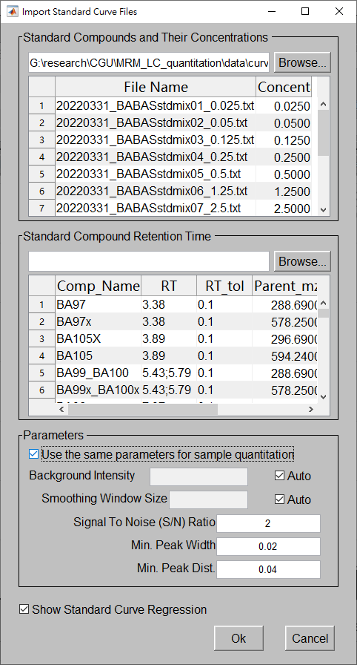

Figure 39. The “Import Standard Curve Files” window for standard curve generation.

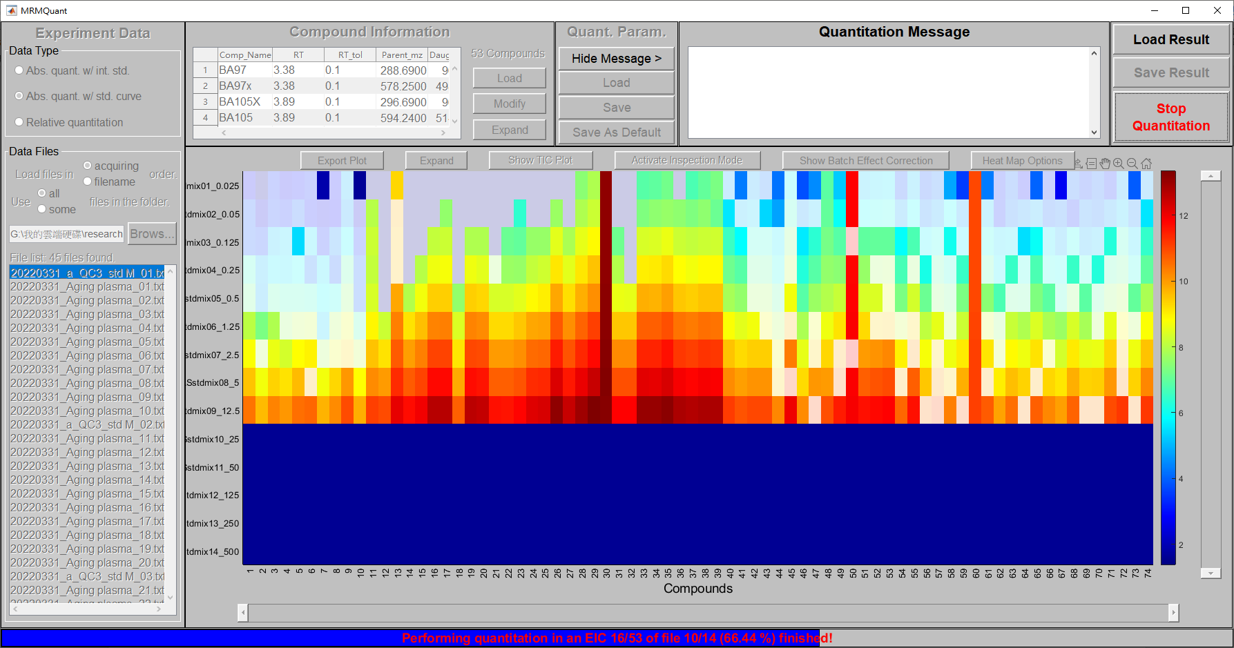

Figure 40. The quantitation is performed on the samples for standard curve generation.

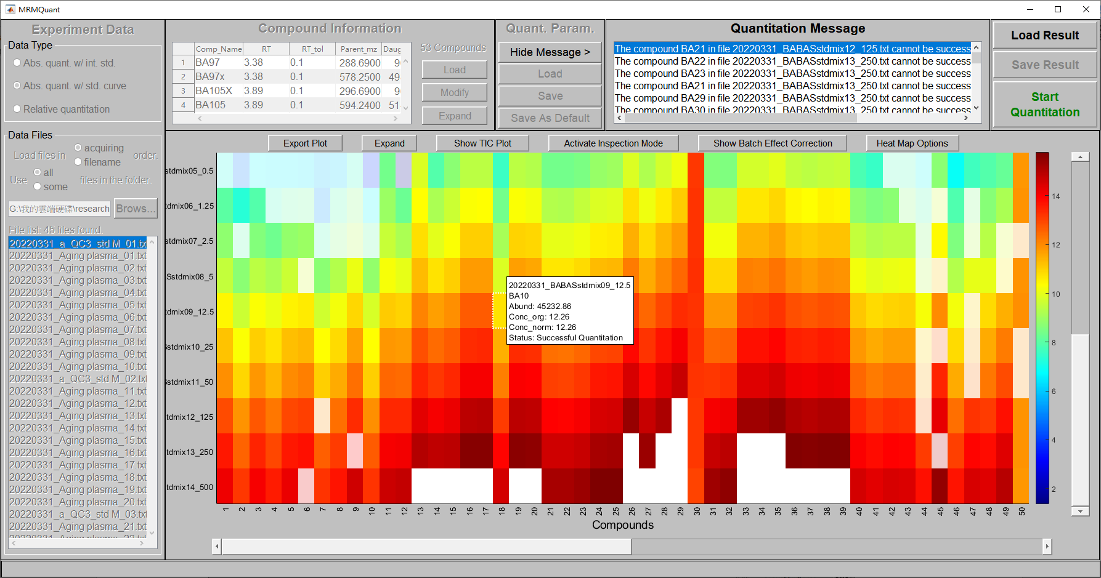

Figure 41. The quantitation result in heat map form of the data for standard curve generation.

After the quantitation of the SC files is finished, a “Standard Curve” window will appear showing the calculated SCs, as shown in panel (a) of Figure 42. Each plot in the window shows a blue line with a "+" mark at the data points indicating the designated compound concentrations (horizontal axis) and their calculated abundances (vertical axis) in. The red line in the plot shows the corresponding regression line (i.e., the SC) of the data points. The plot is shown in linear scale, but can be changed to logarithmic scale to reveal the detail in the small concentration points. By clicking on the regression plot of a compound, the ion chromatograms of the compound in different SC files will be revealed in panel (b), as shown in Figure 42. The user can also choose to skip certain points in the regression plot by unchecking the box next to the ion chromatograms if they do not seem to fit in the curve after the corrections. Saturated peaks are automatically excluded from the regression process for their unreliable abundances, as shown in Figure 43. In panel (c), there are two options to adjust the plots in panel (a) and in panel (b), respectively. On the left-hand side, the “Show log-scaled standard curves” changes the standard curves in panel (a) from linear to logarithmic scale. This option is designed to reveal the regression details in the small values, as shown in Figure 44. The “Show absolute height for the detected height” option is designed to magnify the height of the detected peaks in all the ion chromatograms to compare their shapes across samples, as shown in Figure 45. By default, the peak heights are displayed in the same scale for amplitude comparison. But they can be displayed in the normalized scale for peak shape comparison by selecting the option in panel (c). The user can also click on an ion chromatogram to further inspect and correct the detected peak. Once the correction is made, the SC will be updated.

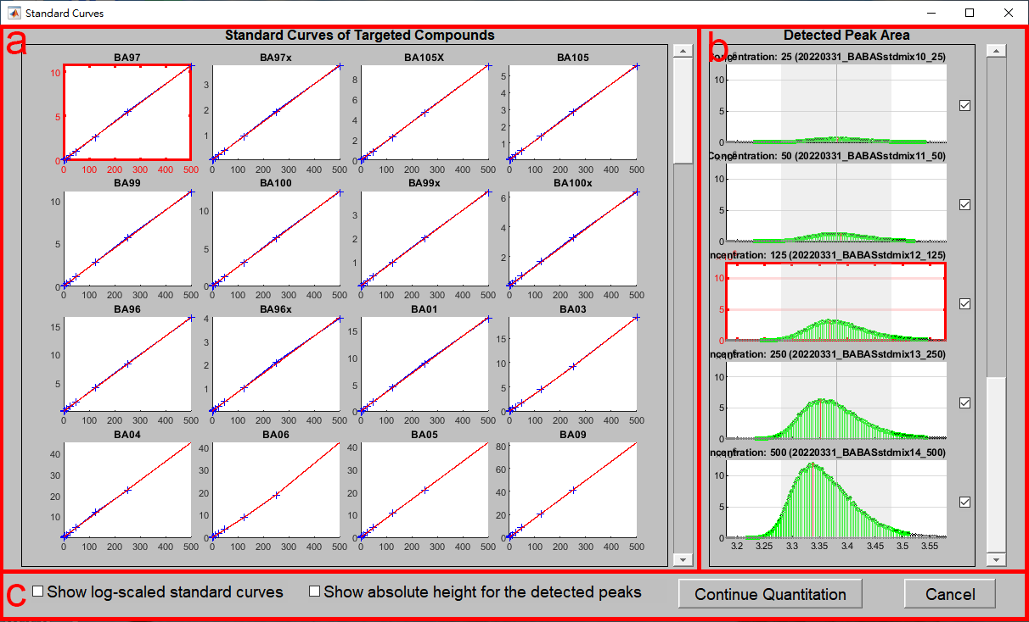

Figure 42. The standard curves for the targeted compounds generated via the sample files of known concentrations. Panel (a) shows the standard curves, whereas panel (b) shows the individual ion chromatograms of the highlighted curve in panel (a). In panel (c), the checkboxes control the linear/logarithmic scale of the standard curves and the height of the peaks in the ion chromatograms, respectively.

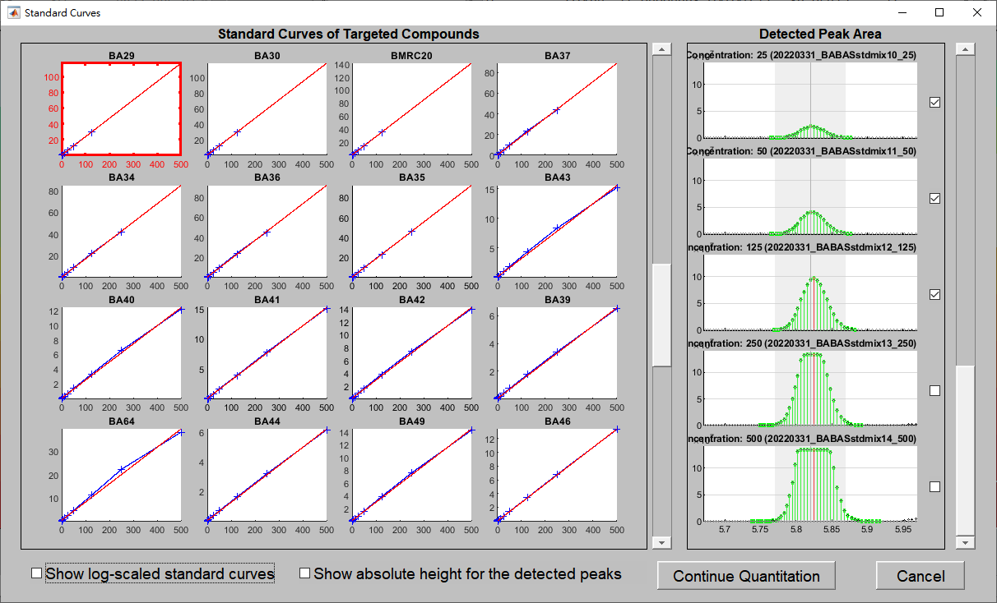

Figure 43. Saturated peaks are automatically excluded from the regression process for their unreliable abundances. The user can also choose to skip certain points in the regression plot by unchecking the box next to the ion chromatograms if they do not seem to fit in the curve after the corrections.

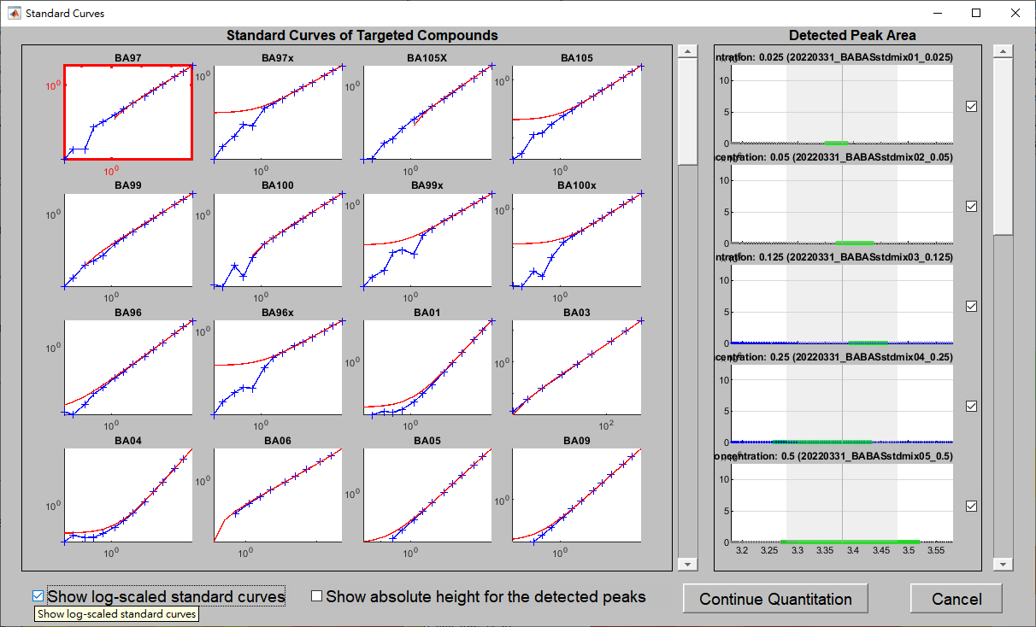

Figure 44. The “Show log-scaled standard curves” changes the standard curves from linear to logarithmic scale to reveal the regression details in the small values.

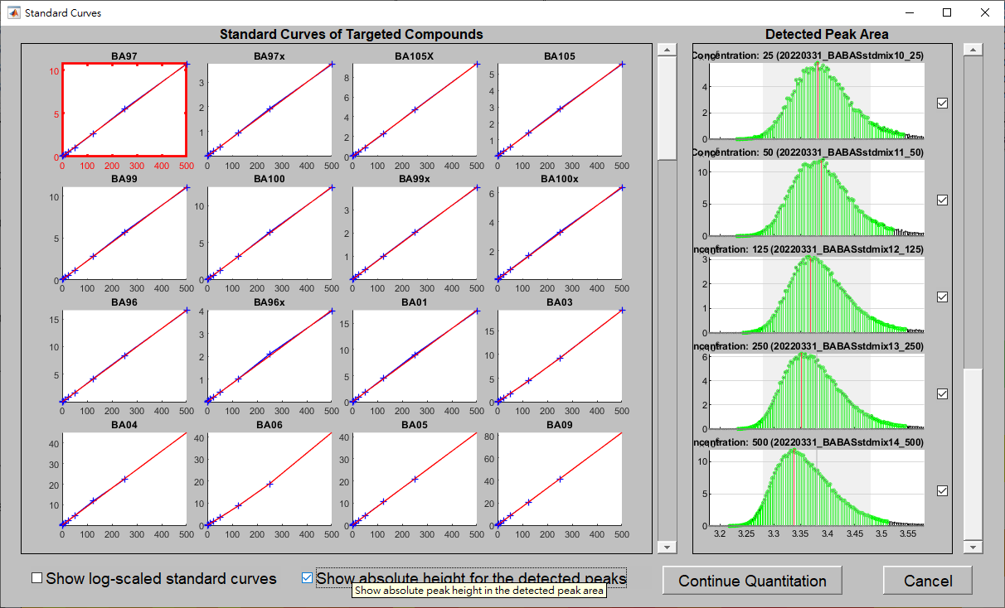

Figure 45. The “Show absolute height for the detected height” option is designed to magnify the height of the detected peaks in all the ion chromatograms to compare their shapes across samples.

However, for samples with low concentration, their signal intensities in the ion chromatogram are usually low and hence susceptible to noise and subsequently lead to inaccurate peak detection and quantitation, as shown in Figure 46. When some of the peaks are not correctly quantitated, the user can click on the corresponding ion chromatogram and it will bring up the Multiple Reaction Monitoring window, as shown in Figure 17. For details about how to use the five correction methods to correct the quantitation, please refer to section **9. Activate/deactivate inspection mode**. Here, we simply demonstrate how to use the “select a reference” method to fix the inconsistency problem of a compound across multiple samples. For example, we click on the fourth chromatogram on the right and it will bring up the Multiple Reaction Monitoring window, as shown in Figure 47.

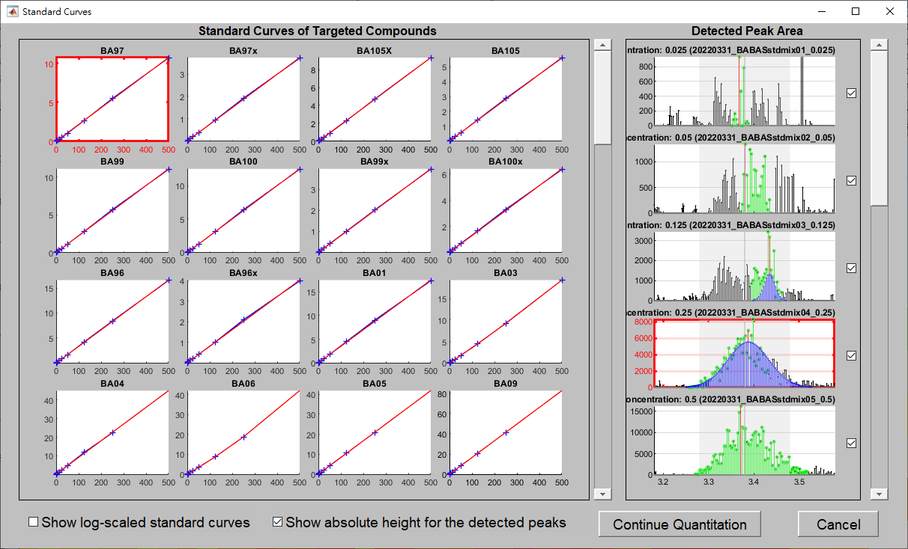

Figure 46. Samples with low concentration, their signal intensities in the chromatogram are usually low and hence susceptible to noise and subsequently lead to inaccurate peak detection and quantitation.

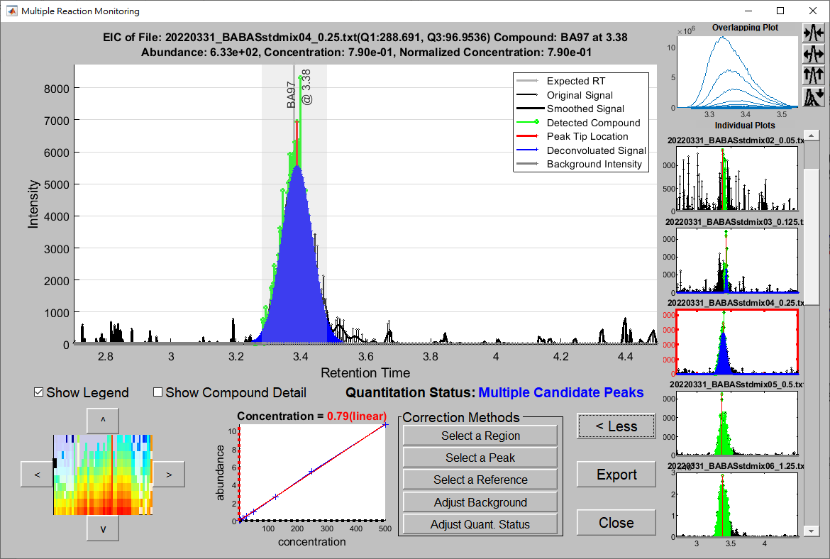

Figure 47. The Multiple Reaction Monitoring window for peak area correction.

In Figure 47, if the “Select a Reference” button is pressed, a window that allows the user to specify the reference sample will be brought up. Because there is only one batch in the standard curve samples, one sample is to be assigned as the reference, as shown in Figure 48. In this case, the sample with concentration 50 is selected as the reference since this sample has higher concentration and thus the compound herein is more likely to has higher peak signals. Although there are samples with higher concentrations (125, 250, 500), they consist of saturation peaks, as shown in Figure 41.

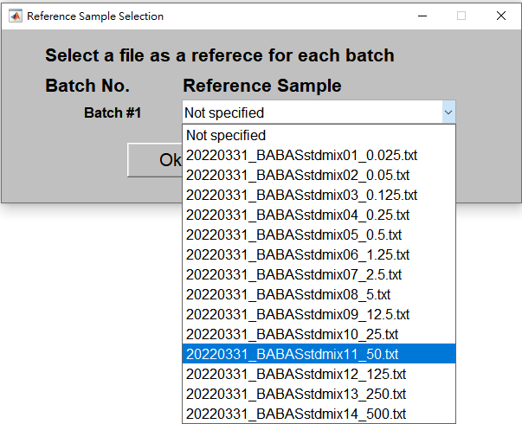

Figure 48. The window for the user to select a reference from candidate samples

As shown in Figure 49, after the correction, the compound peaks in different samples are more consistent since they were identified using a similar RT range as that in the reference. More importantly, the peak areas (abundances) are more consistent (data points are smoother along a curve) in the standard curve, as shown in Figure 50. If no more correction is required, the user can press the “Continue Quantitation” button to quantify the testing samples. Otherwise, the user can press the “Cancel” button to terminate the quantitation process, as shown in Figure 51.

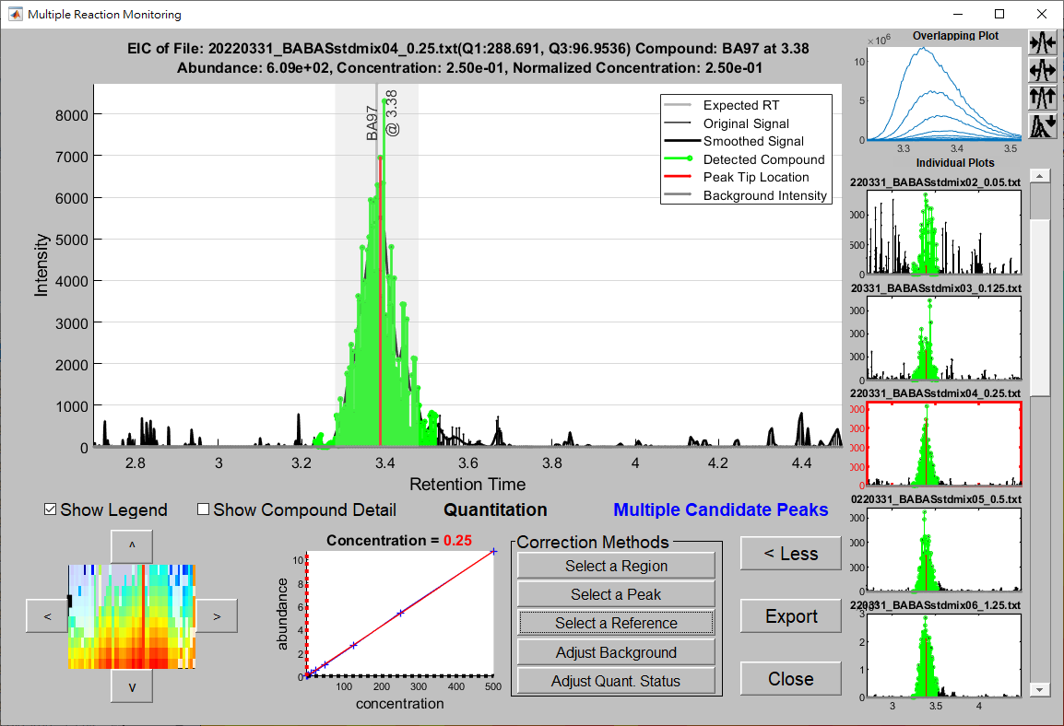

Figure 49. The quantitated peaks in the current sample (middle plot) and in the other samples (plots in the right) are more consistent in RT range after the correction.

|  |  |
| --- | --- |
|  |  |
| (a) | (b) |

Figure 50, Standard curves before and after the “Select a Reference” correction, (a) before the correction and (b) after the correction.

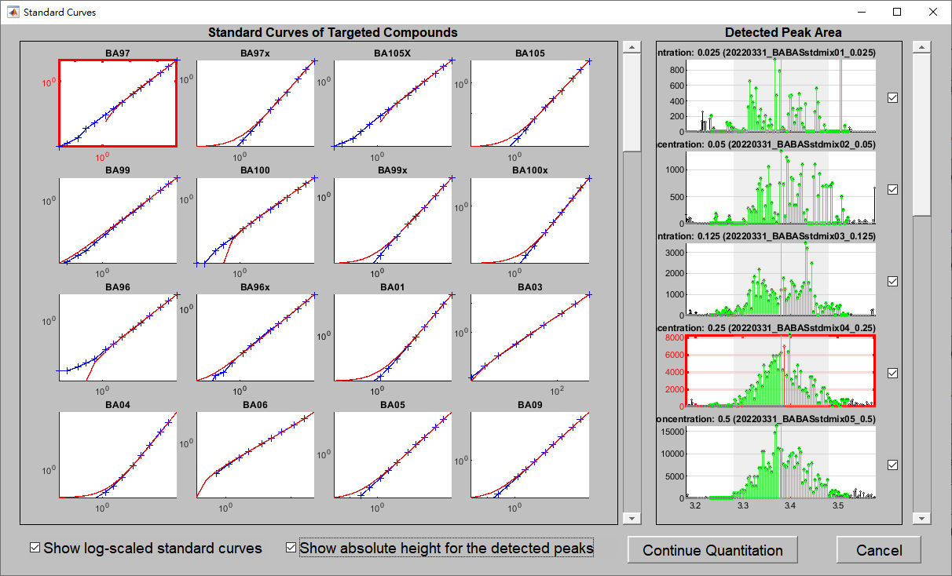

Figure 51. The user can press the “Continue Quantitation” button to quantify the testing samples or press the “Cancel” button to terminate the quantitation process.

1. **Input/Output the quantitation result:** When the quantitation process is completed, a window will appear to ask the user to provide the path and the file name to save the quantitation result. In addition, the user can save the result manually using the “Save Result” button at the upper right corner of the GUI, especially when a correction is made, as shown in Figure 52. The quantitation results are saved in a Microsoft Excel file in the xlsx format, as shown in Figure 53. The results include peak abundance, quantitation status, and RT. If absolute quantitation is performed, the peak concentration is included. In addition, if absolute quantitation is achieved by SC, the peak abundances of the standards and coefficients of the regression formula for SCs are also included. All the above information is saved on a separate sheet in the Microsoft Excel file. For easy access to existing quantitation results, a MATLAB mat file with the same name as the Excel file will also be generated for future inspection and modification. However, it should be noted that when the mat file is larger than 2GB, the save time can increase considerably. If the quantitation mat file is larger than 2GB, a warning message will appear to warn the user for long saving time, as shown in Figure 54. It is highly recommended that the user saves such a file in local drive (e.g. drive C or drive D). Saving large mat files to cloud drive can take a very long time. Furthermore, the user can load the mat file into MRMQuant using the “Load Result” button at the upper right corner of the GUI to inspect and correct the existing quantitation result, and apply different parameter settings to recompute the entire quantitation result.

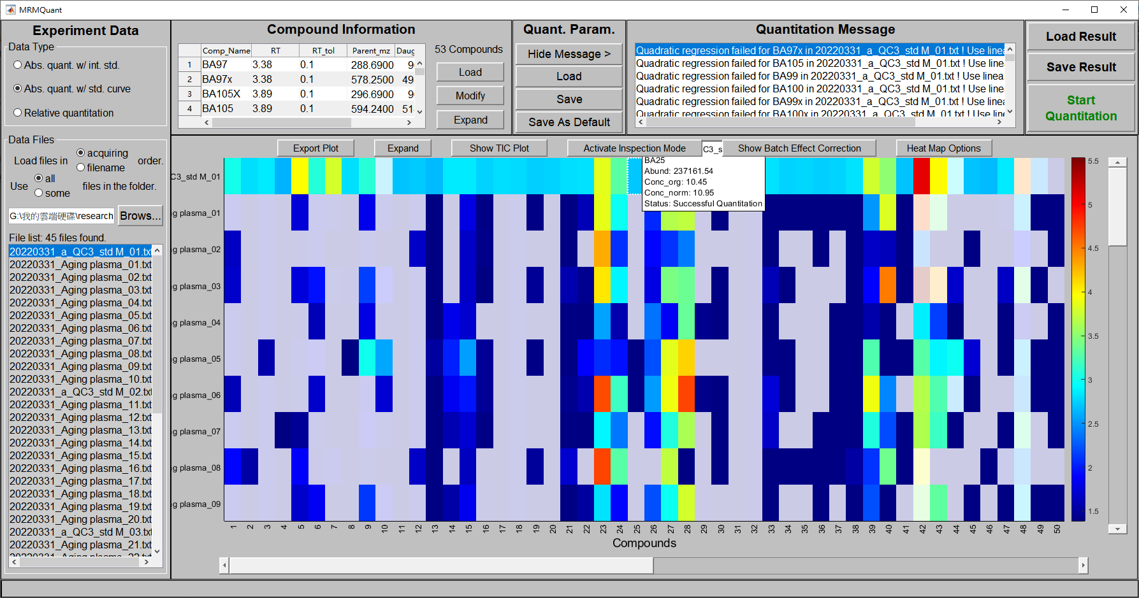

Figure 52. The load result and save result button in the GUI for the user to save a corrected result or to load an existing result manually.



Figure 53. The window allows the user to save the quantitation result to a MS Excel xlsx file.

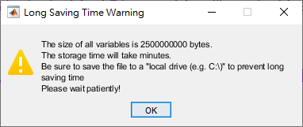

Figure 54. The warning message for long saving time of the quantitation result. It is highly recommended that the user saves such a file in local drive (e.g. drive C or drive D) instead of a cloud drive.



Figure 55. The window allows the user to load the quantitation result from a MATLAB mat file.